PRACTICAL - 01
Part A — Practice Programs (Hour 1)

PROBLEM1 | - Vending machine (VendingMachine.java, main in this file)  - Define an Enum Coin with constants ONE, TWO, FIVE, TEN.  - In main, set a snack price of 15 and a running total of 0; create a Scanner.  - Loop: read a coin name, use a switch expression to convert the Coin to its value (ONE→1, TWO→2, FIVE→5, TEN→10), add it to the total, and print the total so far.  - Stop the loop once the total reaches 15 or more.  - Print the change to return (total − 15).  Expected output: TEN then FIVE prints “Paid. Change: 0”; TEN then TEN prints “Paid.  Change: 5”.
CODE | import java.util.Scanner;  enum Coin {  ONE, TWO, FIVE, TEN  }  public class VendingMachine {  public static void main(String[] args) { Scanner sc = new Scanner(System.in);  int price = 15; int total = 0;  while (total < price) {  Coin coin = Coin.valueOf(sc.next().toUpperCase()); int value = switch (coin) {  case ONE -> 1; case TWO -> 2; case FIVE -> 5; case TEN -> 10;  };  total = total + value; System.out.println("Total so far: " + total);  }  System.out.println("Paid. Change: " + (total - price));

sc.close();
}
}
OUTPUT | 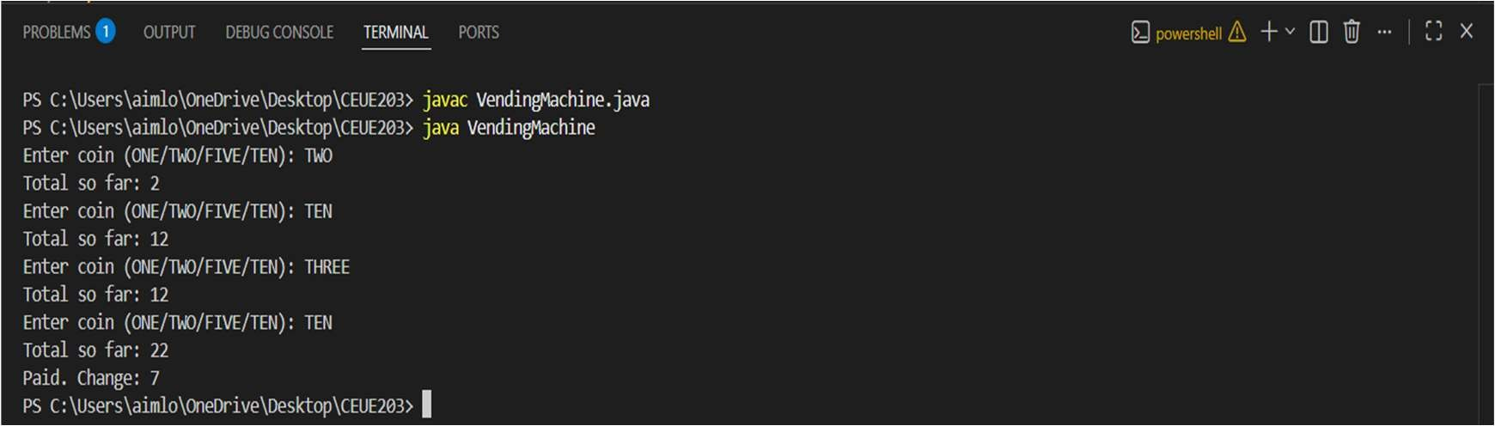
PROBLEM2 | - Toll booth (TollBooth.java, main in this file)  - Define a record Vehicle(String number, String type).  - In main, keep a running toll total and three counters (bike, car, truck).  - Loop until the user types “done” for the number: build a Vehicle, use a switch expression on its type for the toll (bike→20, car→50, truck→150), add to the total, and increment that type’s counter.  - After the loop, print the total toll and the type with the highest count. Expected output: two cars + one bike → “Total toll: 120”, “Most frequent: car”.
CODE | import java.util.Scanner;  enum Coin {  ONE, TWO, FIVE, TEN  }  public class VendingMachine {  public static void main(String[] args) {  Scanner sc = new Scanner(System.in); int price = 15;  int total = 0;  while (total < price) {  Coin coin = Coin.valueOf(sc.next().toUpperCase()); int value = switch (coin) {  case ONE -> 1; case TWO -> 2; case FIVE -> 5; case TEN -> 10;  };  total = total + value;

System.out.println("Total so far: " + total);
}
System.out.println("Paid. Change: " + (total - price)); sc.close();
}
}
OUTPUT | 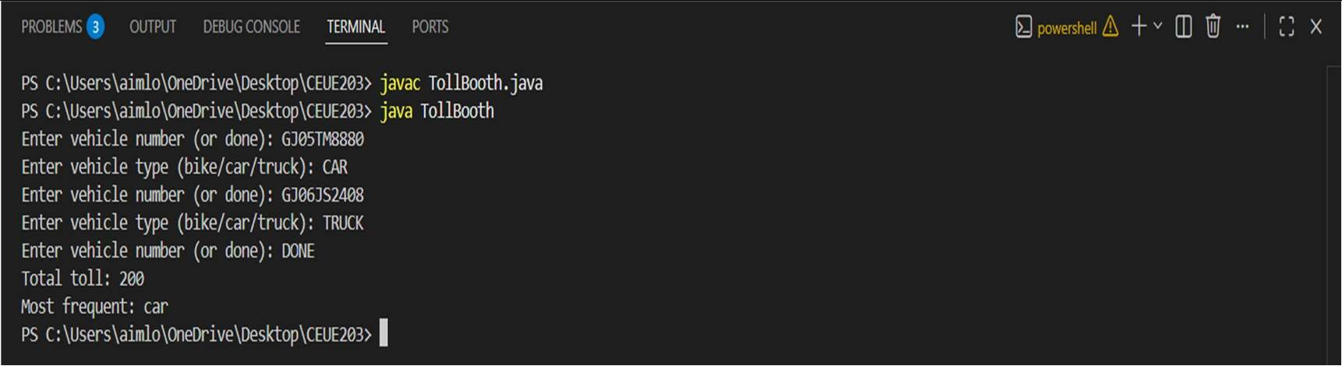
PROBLEM3 | - (For Advanced Learners – home) Rock-Paper-Scissors-Lizard-Spock (RPSLS.java)  - Define an enum Move with ROCK, PAPER, SCISSORS, LIZARD, SPOCK.  - Write winner(Move a, Move b) returning 1 if a beats b, -1 if b beats a, 0 for a tie use a switch expression listing what each move beats (Scissors cut Paper, Paper covers Rock, Rock crushes Lizard, Lizard poisons Spock, Spock smashes Scissors, and the five mirror cases).  - In main, play 5 rounds: pick a random computer Move, read the player’s Move, call winner(), print the round result and keep score.  - After 5 rounds, print the overall winner.  Expected output: each round prints both moves and the round winner; ends with a “You win 3–2” summary.
CODE | import java.util.Random; import java.util.Scanner;  enum Move {  ROCK, PAPER, SCISSORS, LIZARD, SPOCK  }  public class RPSLS {  static int winner(Move a, Move b) { if (a == b) {  return 0;  }  boolean win = switch (a) { case ROCK ->  b == Move.SCISSORS || b == Move.LIZARD;

case PAPER ->
b == Move.ROCK || b == Move.SPOCK;

case SCISSORS ->
b == Move.PAPER || b == Move.LIZARD;

case LIZARD ->
b == Move.SPOCK || b == Move.PAPER;

case SPOCK ->
b == Move.SCISSORS || b == Move.ROCK;
};

if (win) { return 1;
} else {
return -1;
}
}

public static void main(String[] args) { Scanner sc = new Scanner(System.in); Random random = new Random();
int playerScore = 0;
int computerScore = 0;

for (int round = 1; round <= 5; round++) { System.out.println("\nRound " + round); System.out.print("Enter move: ");
Move player =
Move.valueOf(sc.next().toUpperCase());

Move computer = Move.values()[random.nextInt(Move.values().length)];

System.out.println("Player: " + player); System.out.println("Computer: " + computer);
int result = winner(player, computer);

if (result == 1) {

System.out.println("You win this round!"); playerScore++;
} else if (result == -1) { System.out.println("Computer wins this round!"); computerScore++;
} else {

System.out.println("Tie!");
}
}
System.out.println("\nFinal Score"); System.out.println("You " + playerScore
+ " - " + computerScore + " Computer");
if (playerScore > computerScore) { System.out.println("You win "
+ playerScore + "-" + computerScore);
} else if (computerScore > playerScore) { System.out.println("Computer wins "
+ computerScore + "-" + playerScore);

} else {

System.out.println("Overall Tie!");
}

sc.close();
}
}

OUTPUT | 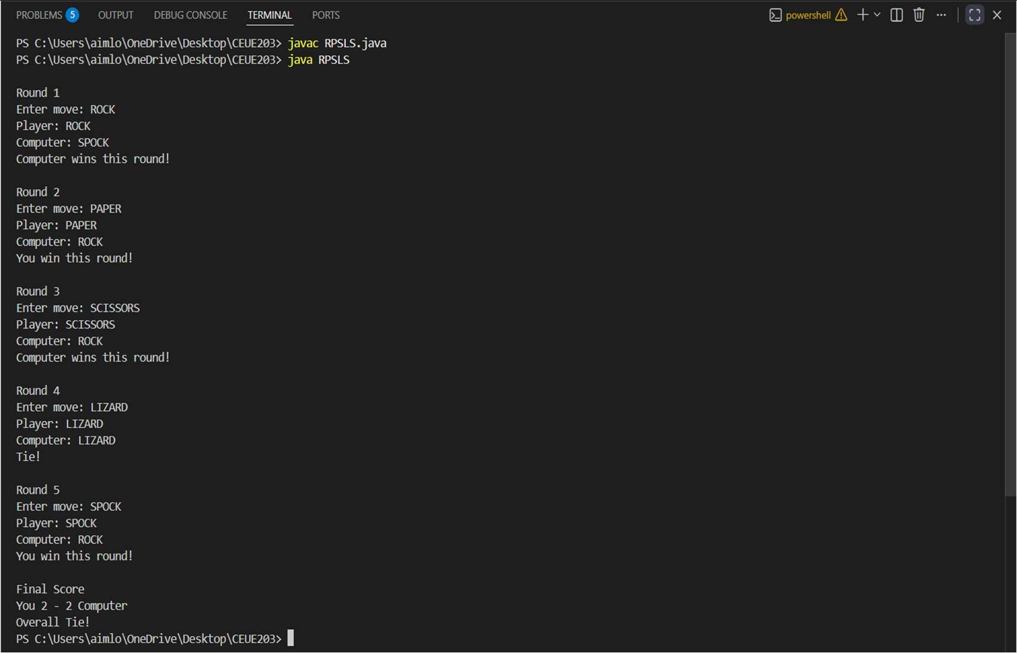

Part B — Project Work (Hour 2): Mini Bank

PROBLEM | MiniBank is the console banking application you will build across the whole semester. In this first lab you set up your tools and create the project and its menu shell — the screen the user navigates. Every later lab attaches one real banking feature behind these menu options.  - Set up your environment: open the project in GitHub Codespaces (or install JDK 17+ and an IDE locally), and create a private GitHub repository named oop-minibank-; add the faculty as a collaborator.  - Create a public class named MiniBank that contains the main method.  - Define a record named BankInfo with two String fields, name and branch (a record is a short, read-only class; Java auto-generates its constructor and field accessors). Print one BankInfo object as the application header.  - Define an enum named MenuOption with the constants OPEN_ACCOUNT, DEPOSIT, WITHDRAW, TRANSFER and EXIT — these are the actions MiniBank will offer.  - Display the numbered menu to the user and read the chosen number with a Scanner.  - Use a switch expression on the choice to print a short placeholder for that option (for example, “Deposit — to be implemented in a later lab”). Keep showing the menu in a loop until the user selects EXIT, then print a goodbye message.

CODE | import java.util.Scanner;  record BankInfo(String name, String branch) {  }  enum MenuOption { OPEN_ACCOUNT, DEPOSIT, WITHDRAW, TRANSFER,  EXIT  }  public class MiniBank {  public static void main(String[] args) { Scanner sc = new Scanner(System.in);  BankInfo bank = new BankInfo("MiniBank", "Main Branch");  System.out.println("================================");  System.out.println(bank); System.out.println("================================");  boolean running = true; while (running) {  System.out.println("\n1. Open Account"); System.out.println("2. Deposit"); System.out.println("3. Withdraw"); System.out.println("4. Transfer"); System.out.println("5. Exit");  System.out.print("Enter your choice: "); int choice = sc.nextInt();  MenuOption option = switch (choice) { case 1 -> MenuOption.OPEN_ACCOUNT; case 2 -> MenuOption.DEPOSIT;  case 3 -> MenuOption.WITHDRAW; case 4 -> MenuOption.TRANSFER; case 5 -> MenuOption.EXIT; default -> null;  };

if (option == null) {
System.out.println("Invalid choice. Please enter 1 to 5."); continue;
}
 |  |  | String message = switch (option) {
case OPEN_ACCOUNT ->
"Open Account - to be implemented in a later lab";
case DEPOSIT ->
"Deposit - to be implemented in a later lab";
case WITHDRAW ->
"Withdraw - to be implemented in a later lab";
case TRANSFER ->
"Transfer - to be implemented in a later lab";
case EXIT ->
"Goodbye! Thank you for using MiniBank.";
};
 |  |  | System.out.println(message);
if (option == MenuOption.EXIT) { running = false;
}
}
 | } | } | sc.close();
OUTPUT | 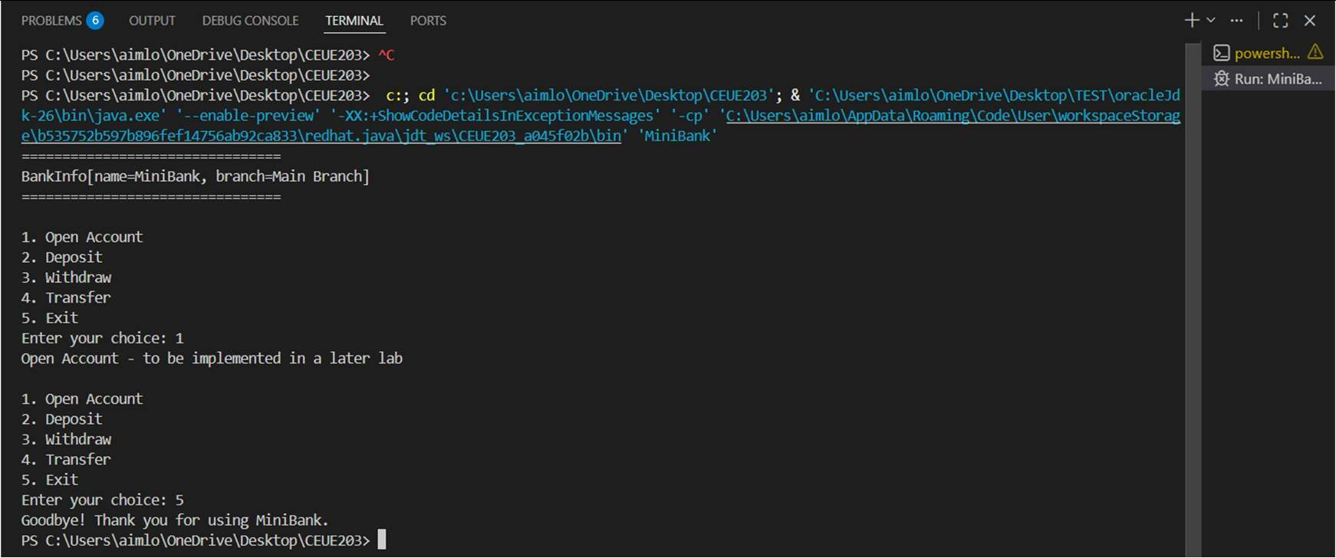

PRACTICAL - 02
Part A — Practice Programs (Hour 1)

PROBLEM1 | 1. Smart thermostat (Thermostat.java, main in this file)  - Create class Thermostat with private String location, private int temperature, private static final int MIN=16 and MAX=30, and private static int activeCount=0.  - Constructor(location, startTemp): store location; set temperature to startTemp if it is within MIN..MAX else 22; increment activeCount.  - Constructor(location): chain with this(location, 22).  - raise(): if temperature < MAX add 1, else print “Already at maximum (30)”.  - lower(): if temperature > MIN subtract 1, else print “Already at minimum (16)”.  - Add getTemperature() (no setter) and static getActiveCount().  - In main: create two thermostats, call raise() 10 times then lower() 20 times in loops (printing the temperature each time), then print getActiveCount().  Expected output: temperature rises to 30 then “Already at maximum”, falls to 16 then “Already at minimum”, count 2.
CODE | public class Thermostat { private String location; private int temperature;  private static final int MIN = 16; private static final int MAX = 30; private static int activeCount = 0;  public Thermostat(String location, int startTemp) { this.location = location;  if (startTemp >= MIN && startTemp <= MAX) temperature = startTemp;  else  temperature = 22; activeCount++;  }  public Thermostat(String location) { this(location, 22);

 |  | }
public void raise() {
if (temperature < MAX) temperature++;
else
System.out.println("Already at maximum (30)");
}
public void lower() {
if (temperature > MIN) temperature--;
else
System.out.println("Already at minimum (16)");
}
public int getTemperature() { return temperature;
}
public static int getActiveCount() { return activeCount;
}
public static void main(String[] args) {
Thermostat t1 = new Thermostat("Living Room", 22); Thermostat t2 = new Thermostat("Bedroom");
for (int i = 0; i < 10; i++) { t1.raise();
System.out.println(t1.getTemperature());
}
for (int i = 0; i < 20; i++) { t1.lower();
System.out.println(t1.getTemperature());
}
 | } | System.out.println(Thermostat.getActiveCount());  }

OUTPUT | 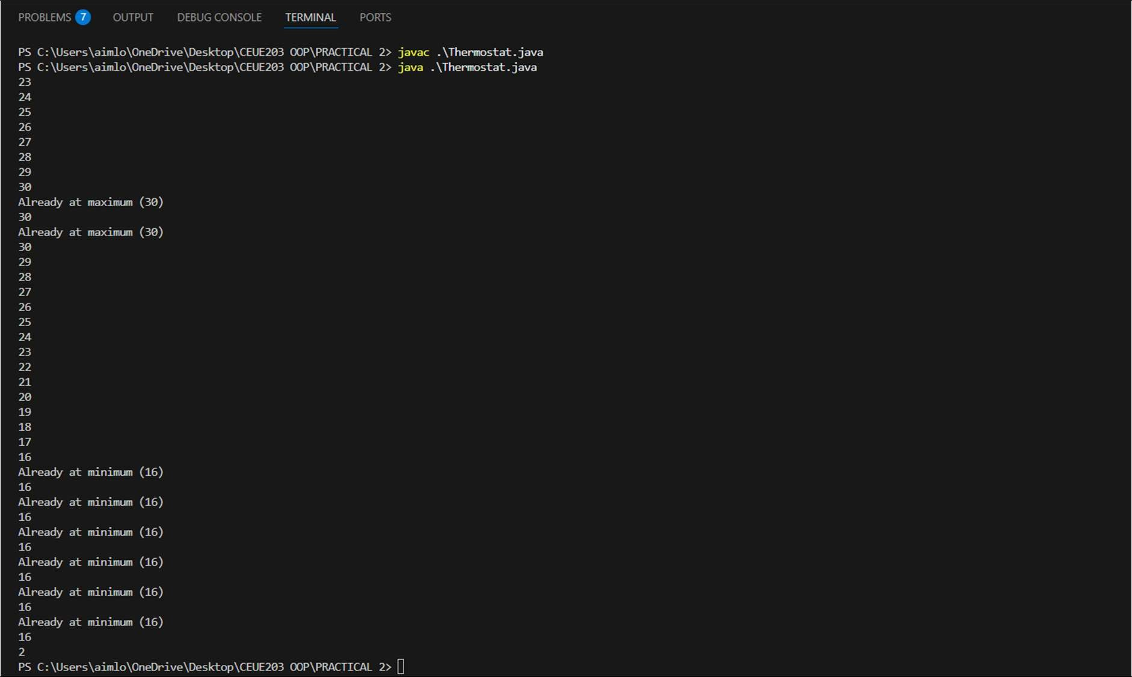
PROBLEM2 | 2. Cinema show (CinemaShow.java, main in this file)  - Create class CinemaShow with private String title, private int seatsAvailable, private final int capacity, and private static int totalBooked = 0.  - Constructor(title, capacity): set both and seatsAvailable = capacity. Constructor(title): chain with this(title, 100).  - book(int n): if n ≤ seatsAvailable, reduce seatsAvailable by n, add n to totalBooked, return true; else return false unchanged.  - cancel(int n): increase seatsAvailable by n but never above capacity.  - Add getSeatsAvailable() and static getTotalBooked().  - In main, run a sequence of book() and cancel() calls, printing the result and seats after each, then print getTotalBooked().  Expected Output: Booking more than available prints false and leaves seats unchanged; totalBooked equals the successful bookings.

CODE | public class CinemaShow { private String title; private int seatsAvailable; private final int capacity;  private static int totalBooked = 0;  public CinemaShow(String title, int capacity) { this.title = title;  this.capacity = capacity; seatsAvailable = capacity;  }  public CinemaShow(String title) { this(title, 100);  }  public boolean book(int n) { if (n <= seatsAvailable) { seatsAvailable -= n; totalBooked += n;  return true;  }  return false;  }  public void cancel(int n) { seatsAvailable += n;  if (seatsAvailable > capacity) seatsAvailable = capacity;  }  public int getSeatsAvailable() { return seatsAvailable;  }  public static int getTotalBooked() { return totalBooked;  }  public static void main(String[] args) {  CinemaShow show = new CinemaShow("Avengers", 50);  System.out.println(show.book(20)); System.out.println(show.getSeatsAvailable());  System.out.println(show.book(15)); System.out.println(show.getSeatsAvailable());

System.out.println(show.book(20)); System.out.println(show.getSeatsAvailable());

show.cancel(10); System.out.println(show.getSeatsAvailable());

System.out.println(show.book(15)); System.out.println(show.getSeatsAvailable());

System.out.println(CinemaShow.getTotalBooked());
}
}
OUTPUT | 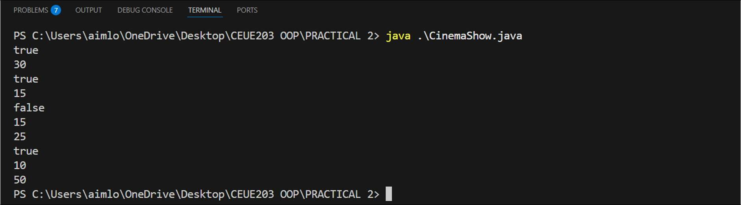
PROBLEM3 | 3. (For Advanced Learners – home) Parking lot (ParkingLot.java)  - Create class ParkingLot with private int twoWheelers and fourWheelers, private final int twoCap and fourCap, and private static long revenue = 0.  - park(String type): for "two", if twoWheelers < twoCap increment and add 20 to revenue; for "four", if fourWheelers < fourCap increment and add 40 to revenue; otherwise print "Full" and reject.  - leave(String type): decrement the matching count but never below 0.  - In main, simulate a sequence of park() and leave() events, printing each outcome, then print final occupancy and revenue.  Expected Output: Parking into a full section is refused; revenue = 20 × (two parked) + 40 × (four parked).
CODE | public class ParkingLot { private int twoWheelers; private int fourWheelers; private final int twoCap; private final int fourCap;  private static long revenue = 0;  public ParkingLot(int twoCap, int fourCap) {

this.twoCap = twoCap; this.fourCap = fourCap;
}

public void park(String type) { if (type.equals("two")) {
if (twoWheelers < twoCap) { twoWheelers++;
revenue += 20;
System.out.println("Two-wheeler parked");
} else {
System.out.println("Full");
}
} else if (type.equals("four")) { if (fourWheelers < fourCap) {
fourWheelers++; revenue += 40;
System.out.println("Four-wheeler parked");
} else {
System.out.println("Full");
}
}
}

public void leave(String type) { if (type.equals("two")) {
if (twoWheelers > 0) twoWheelers--;
} else if (type.equals("four")) { if (fourWheelers > 0)
fourWheelers--;
}
}

public static void main(String[] args) { ParkingLot p = new ParkingLot(2, 2);

p.park("two");
p.park("two");
p.park("two");

p.park("four");
p.park("four");
p.park("four");

p.leave("two");
System.out.println("Two Wheelers: " + p.twoWheelers);

p.leave("four");
System.out.println("Four Wheelers: " + p.fourWheelers);

System.out.println("Revenue: " + revenue);
}
}
OUTPUT | 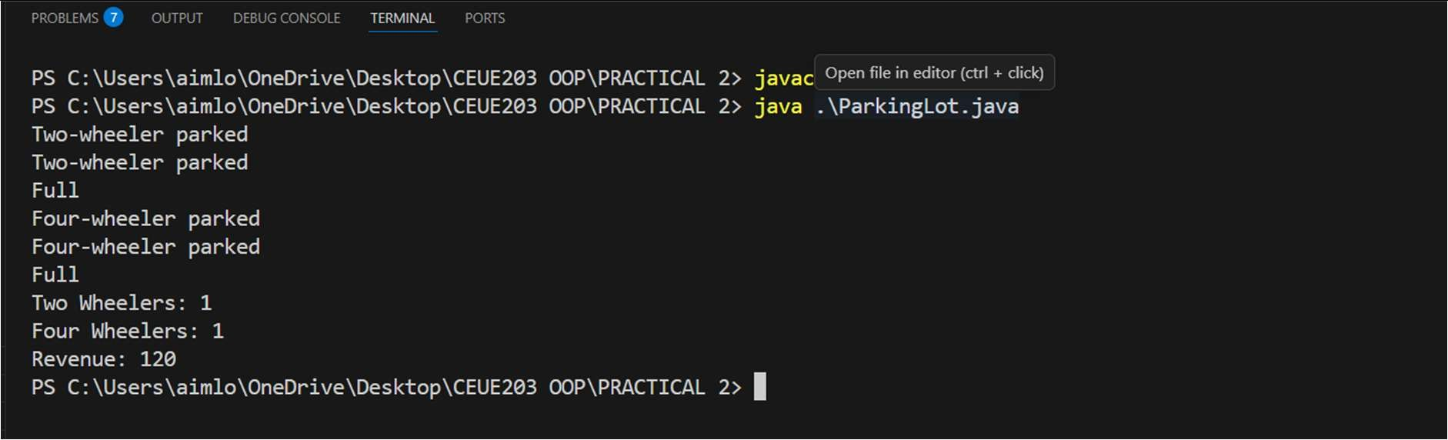

Part B — Project Work (Hour 2): Mini Bank

PROBLEM | MiniBank is the console banking application you will build across the whole semester. In this first lab you set up your tools and create the project and its menu shell — the screen the user navigates. Every later lab attaches one real banking feature behind these menu options.  - Set up your environment: open the project in GitHub Codespaces (or install JDK 17+ and an IDE locally), and create a private GitHub repository named oop-minibank-; add the faculty as a collaborator.  - Create a public class named MiniBank that contains the main method.  - Define a record named BankInfo with two String fields, name and branch (a record is a short, read-only class; Java auto-generates its constructor and field accessors). Print one BankInfo object as the application header.  - Define an enum named MenuOption with the constants OPEN_ACCOUNT, DEPOSIT, WITHDRAW, TRANSFER and EXIT — these are the actions MiniBank will offer.  - Display the numbered menu to the user and read the chosen number with a Scanner.  - Use a switch expression on the choice to print a short placeholder for that option (for example, “Deposit — to be implemented in a later lab”). Keep showing the menu in a loop until the user selects EXIT, then print a goodbye message.
CODE | public class MiniBank {  public static void main(String[] args) {  Customer c1 = new Customer("Om Sutariya", "om@gmail.com", "9930030060"); Account[] accounts = new Account[3];

accounts[0] = new Account(c1.getName(), 5000); accounts[1] = new Account("Bhavy", 3000); accounts[2] = new Account("Manthan");

accounts[0].deposit(1000); accounts[0].withdraw(2000);

accounts[1].deposit(500); accounts[1].withdraw(1000);

accounts[2].deposit(2000); accounts[2].withdraw(500);

for (Account a : accounts) {
System.out.println(a.getAccountNumber() + " " + a.getOwnerName() + " Balance: " + a.getBalance());
}
}
}

class Customer {

private String name; private String email; private String mobile;
private final String customerId;
private static long customerCounter = 101; private static String generateCustomerId() {
return "CUST" + customerCounter++;
}

public Customer(String name, String email, String mobile) { this.name = name;
this.email = email; this.mobile = mobile;
this.customerId = generateCustomerId();
}

public String getName() { return name;
}

public String getEmail() { return email;
}

public String getMobile() { return mobile;
}

public String getCustomerId() { return customerId;
}
}

class Account {

private final String accountNumber; private String ownerName;
private long balance; private boolean active;

private static int accountCounter = 1;

private static String generateAccountNumber() { return String.format("AC%04d", accountCounter++);
}

public Account(String ownerName, long balance) { this.accountNumber = generateAccountNumber(); this.ownerName = ownerName;
this.balance = balance; this.active = true;
}

public Account(String ownerName) { this(ownerName, 0);
}

public void deposit(long amount) { if (amount < 0)
return;
balance += amount;
}

public boolean withdraw(long amount) { if (amount < 0)
return false;

if (balance >= amount) {
balance -= amount; return true;

 |  | }
 |  | return false;
 |  | }
 |  | public String getAccountNumber() {
 |  | return accountNumber;
 |  | }
 |  | public String getOwnerName() {
 |  | return ownerName;
 |  | }
 |  | public long getBalance() {
 |  | return balance;
 |  | }
 |  | public boolean isActive() {
 |  | return active;
 |  | }
 | }
OUTPUT | 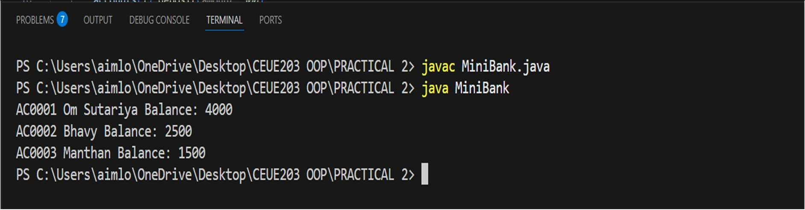

PRACTICAL - 03
Part A — Practice Programs (Hour 1)

PROBLEM1 | - Distinct points (Point.java + Driver.java with main)  - Create class Point with private int x, y and a constructor.  - Override toString() to return “(x, y)”.  - Override equals(Object) to be true when both x and y match, and hashCode() (e.g. Objects.hash(x, y)).  - In Driver.main: build a Point[] with some repeated coordinates.  - Count distinct points: for each point, use equals() to check whether it already appeared earlier; count those that did not.  - Print “Distinct: N”.  Expected output: 5 points with 2 repeats → “Distinct: 3”.
CODE | public class Point { private int x, y;  public Point(int x, int y) { this.x = x;  this.y = y;  }  public void print() {  System.out.print("(" + x + ", " + y + ")");  }  public boolean isSame(Point other) {  return this.x == other.x CC this.y == other.y;  }  }  public class Driver {  public static void main(String[] args) { Point[] pts = {  new Point(1, 2),  new Point(3, 4),  new Point(1, 2),  new Point(5, 6),  new Point(3, 4)  };  int count = 0;  for (int i = 0; i < pts.length; i++) { boolean seen = false;  for (int j = 0; j < i; j++) {  if (pts[i].isSame(pts[j])) {

seen = true; break;
}
}
if (!seen) count++;
}
System.out.println("Distinct: " + count);
}
}
OUTPUT | 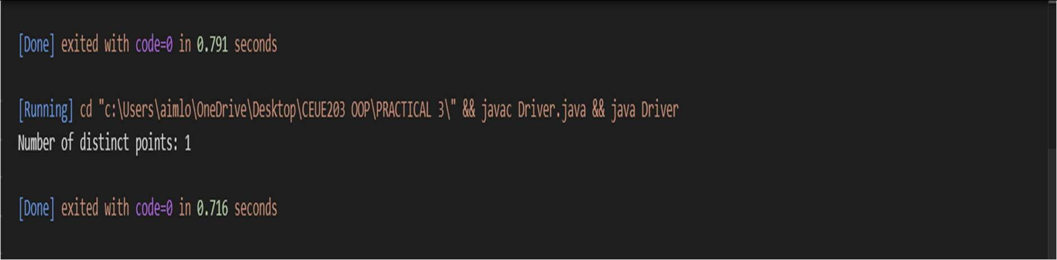
PROBLEM2 | - Duplicate card check (Card.java + Driver.java)  - Create class Card with private String rank, suit and a constructor.  - Override toString() to return rank + “ of ” + suit (e.g. “Queen of Hearts”).  - Override equals()/hashCode() by rank + suit.  - In Driver.main: add cards to a Card[] one at a time; before adding each, use equals() to check it against the earlier cards.  - Print “Duplicate found: <card>” the first time a repeat appears.  Expected output: a second “Ace of Spades” → “Duplicate found: Ace of Spades”.
CODE | public class Card { private String rank, suit;  public Card(String rank, String suit) { this.rank = rank;  this.suit = suit;  }  public void print() { System.out.print(rank + " of " + suit);  }  public boolean isSame(Card other) {  return this.rank.equals(other.rank) CC this.suit.equals(other.suit);  }  }  public class CardTest {  public static void main(String[] args) { Card[] cards = new Card[5];  int size = 0;

Card[] newCards = {
new Card("Ace", "Spades"),
new Card("King", "Hearts"),
new Card("Ǫueen", "Hearts"),
new Card("Ace", "Spades"),
new Card("Jack", "Clubs")
};

for (Card c : newCards) { boolean dup = false;
for (int i = 0; i < size; i++) { if (cards[i].isSame(c)) {
dup = true; break;
}
}
if (dup) {
System.out.print("Duplicate found: "); c.print();
System.out.println(); break;
}
cards[size] = c; size++;
}
}
}
OUTPUT | 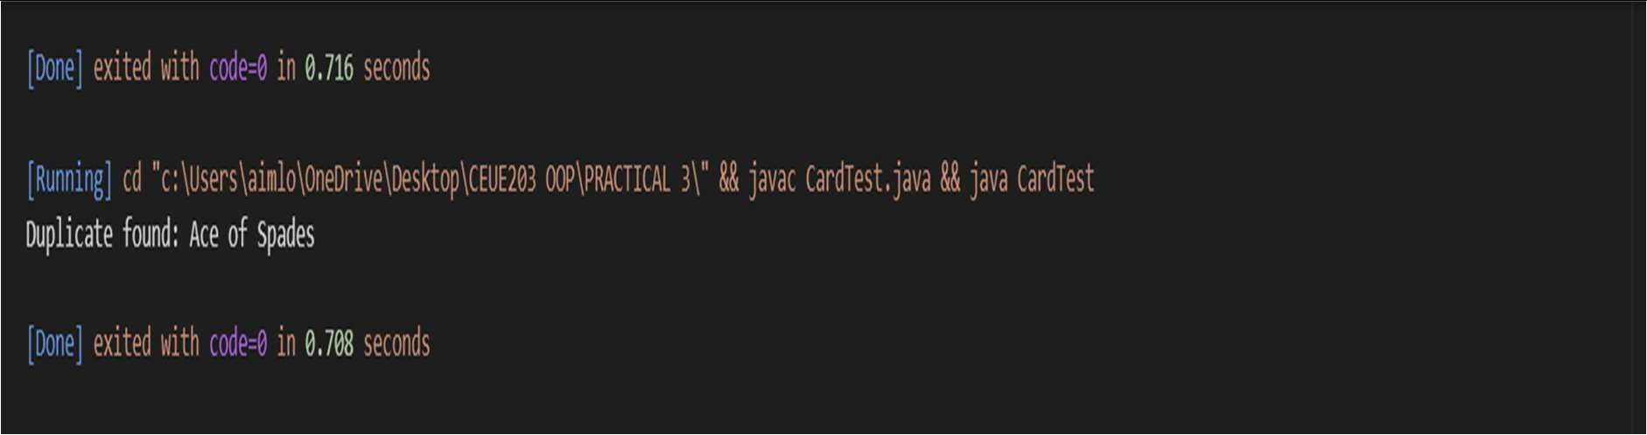
PROBLEM3 | 3. (For Advanced Learners – home) Fractions (Fraction.java + Driver.java)  - Create class Fraction with private int num, den.  - In the constructor, reduce to lowest terms: compute g = gcd(num, den) and divide both by g.  - Override toString() to return num + “/” + den.  - Override equals()/hashCode() using the reduced num and den.  - In Driver.main: create several equivalent fractions (1/2, 2/4, 3/6) and confirm they are all equal and print the same.  Expected output: new Fraction(2,4) prints “1/2” and equals new Fraction(1,2).

CODE | public class Fraction { private int num, den;  public Fraction(int num, int den) {  int g = gcd(Math.abs(num), Math.abs(den)); this.num = num / g;  this.den = den / g;  }  private int gcd(int a, int b) { if (b == 0) return a; return gcd(b, a % b);  }  public void print() { System.out.print(num + "/" + den);  }  public boolean isSame(Fraction other) {  return this.num == other.num CC this.den == other.den;  }  }  public class FractionTest {  public static void main(String[] args) { Fraction a = new Fraction(1, 2); Fraction b = new Fraction(2, 4); Fraction c = new Fraction(3, 6);  a.print(); System.out.println(); b.print(); System.out.println(); c.print(); System.out.println();  System.out.println("a equals b: " + a.isSame(b)); System.out.println("b equals c: " + b.isSame(c)); System.out.println("a equals c: " + a.isSame(c));  }  }

OUTPUT | 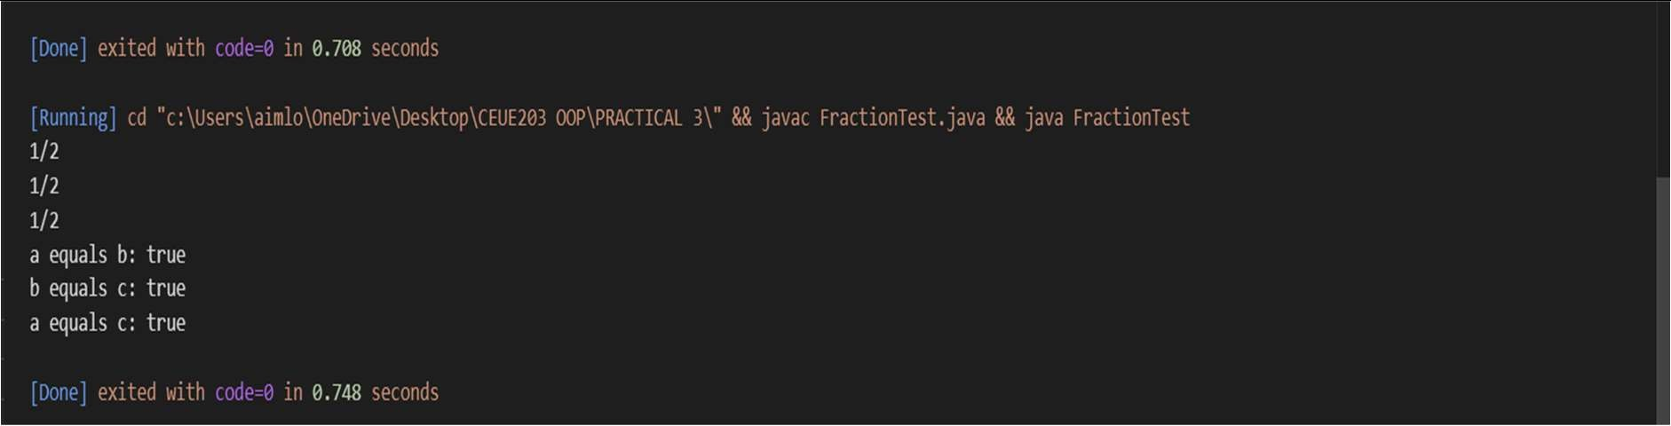

Part B — Project Work (Hour 2): Mini Bank

PROBLEM | In Practical 2 you created the Account and Customer classes. Here you make their objects behave correctly — they print as readable text (toString) and are compared by account number (equals/hashCode) — and you add a nested Address class. Correct equals/hashCode is essential because Practical 12 will store accounts in collections that rely on it.  - In Account, override the toString() method to return a readable line containing accountNumber, ownerName and balance.  - In Account, override equals(Object o) and hashCode() so that two accounts are equal when their accountNumber values are equal.  - In Customer, add a public static nested class named Address with String fields line, city and pincode plus getters; add an Address field to Customer and a getAddress() method.  - In Customer, add a clone() method (implement Cloneable) that returns a copy of the customer.  - In main, print accounts using toString(), compare two Account objects with equals(), and  use instanceof to check an object’s type.
CODE | public class MiniBank {  public static void main(String[] args) throws CloneNotSupportedException { Customer.Address addr = new Customer.Address(  "Atmiya Society", "Vadodara", "390001");  Customer c = new Customer( "Om Sutariya", "om@gmail.com", "9930030060",  addr);  Customer c2 = c.clone(); Account[] acc = new Account[3];

acc[0] = new Account(c.getName(), 5000); acc[1] = new Account("Bhavy", 3000); acc[2] = new Account("Manthan");

acc[0].deposit(1000); acc[0].withdraw(2000);

acc[1].deposit(500); acc[1].withdraw(1000);

acc[2].deposit(2000); acc[2].withdraw(500);
System.out.println("Accounts:"); for (Account a : acc) {
System.out.println(a.toString());
}

System.out.println();

System.out.println("Comparing Accounts:"); System.out.println(acc[0].equals(acc[1])); System.out.println(acc[0].equals(acc[0]));

Object obj = acc[0];

if (obj instanceof Account) { System.out.println("obj is an Account object.");
}

if (c2 instanceof Customer) { System.out.println("c2 is a Customer object.");
}
}
}
class Customer implements Cloneable { private String name;
private String email; private String phone; private final String id; private Address addr;

private static long count = 101;

private static String createId() { return "CUST" + count++;
}

public Customer(String name, String email, String phone, Address addr) { this.name = name;
this.email = email; this.phone = phone; this.addr = addr; this.id = createId();
}

public String getName() { return name;
}

public String getEmail() { return email;
}

public String getPhone() { return phone;
}

public String getId() { return id;
}

public Address address() { return addr;
}

public Customer clone() throws CloneNotSupportedException { return (Customer) super.clone();
}

public static class Address {

private String line; private String city; private String pincode;

public Address(String line, String city, String pincode) { this.line = line;
this.city = city; this.pincode = pincode;
}

public String getLine() { return line;
}

public String getCity() { return city;
}

public String getPincode() { return pincode;
}
}
}

class Account {

private final String accNo; private String owner; private long bal;
private boolean active; private static int count = 1;
private static String createAccNo() {
return String.format("AC%04d", count++);
}

public Account(String owner, long bal) { this.accNo = createAccNo(); this.owner = owner;
this.bal = bal; this.active = true;
}

public Account(String owner) { this(owner, 0);
}

public void deposit(long amount) { if (amount < 0)
return;

bal += amount;
}

public boolean withdraw(long amount) {

if (amount < 0) return false;

if (bal >= amount) { bal -= amount; return true;
}

return false;
}

public String getAccNo() { return accNo;
}

public String getOwner() { return owner;
}

public long getBal() { return bal;
}

public boolean isActive() { return active;
}

public String toString() {
return accNo + " " + owner + " Balance: " + bal;
}
public boolean equals(Object o) { if (this == o)
return true;

if (!(o instanceof Account)) return false;
Account a = (Account) o; return accNo.equals(a.accNo);
}

public int hashCode() { return accNo.hashCode();

}
}
OUTPUT | 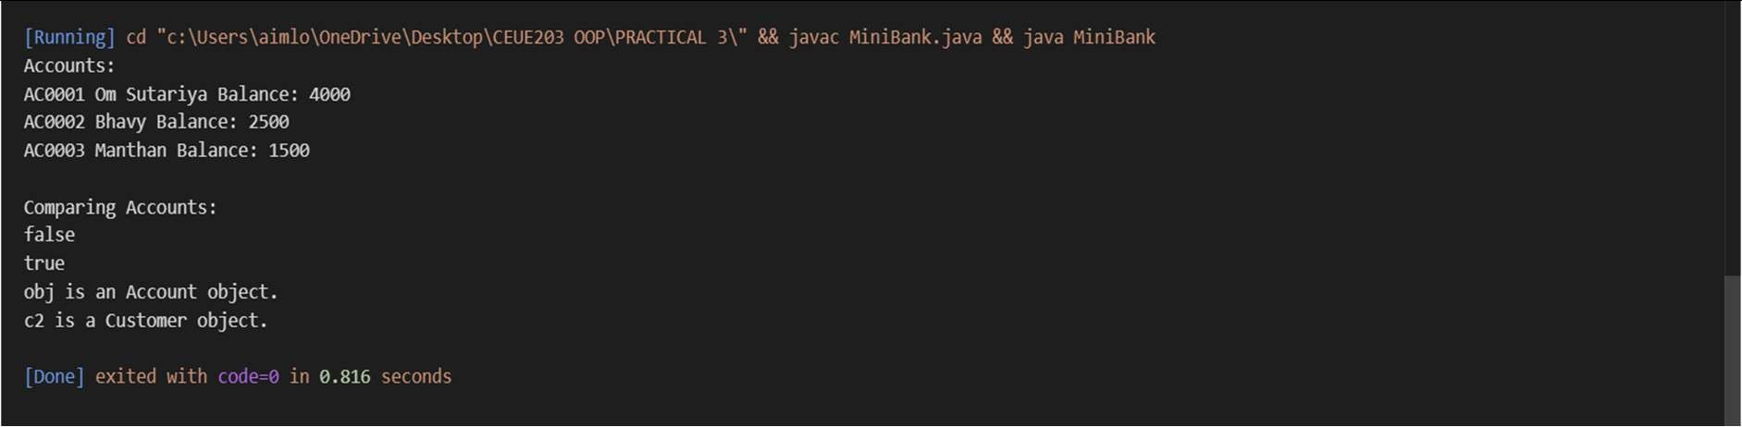

PRACTICAL - 04
Part A — Practice Programs (Hour 1)

PROBLEM1 | - Password Strength (PasswordChecker.java + Driver.java)  - In PasswordChecker, check four rules - length >= 8, contains an uppercase letter, contains a digit, contains a special character - using regex (e.g. .[A-Z].) or String methods.  - Write strength(String pw) that counts how many rules pass and returns "Weak" (0-1), "Medium" (2-3) or "Strong" (4).  - In Driver.main, test several passwords. For each, print which rules passed and the final label.  Expected Output: "abc" -> Weak; "Abcd1234!" -> Strong.
CODE | public class PasswordChecker {  public static boolean hasLength(String pw) { return pw.length() >= 8;  }  public static boolean hasUppercase(String pw) { return pw.matches(".*[A-Z].*");  }  public static boolean hasDigit(String pw) { return pw.matches(".*[0-9].*");  }  public static boolean hasSpecial(String pw) { return pw.matches(".*[^a-zA-Z0-9].*");  }  public static String strength(String pw) { int count = 0;  if (hasLength(pw)) count++;  if (hasUppercase(pw)) count++;

if (hasDigit(pw)) count++;

if (hasSpecial(pw)) count++;

if (count <= 1) return "Weak";
else if (count <= 3) return "Medium";
else
return "Strong";
}
}

DRIVER CLASS

public class Driver {
public static void main(String[] args) { String[] passwords = {
"abc", "Password", "Pass1234", "Abcd1234!",
"hello@12", "WELCOME1"
};

for (String pw : passwords) { System.out.println("Password: " + pw);
System.out.println("Length >= 8 : " + PasswordChecker.hasLength(pw)); System.out.println("Uppercase : " + PasswordChecker.hasUppercase(pw)); System.out.println("Digit : " + PasswordChecker.hasDigit(pw)); System.out.println("Special Char: " + PasswordChecker.hasSpecial(pw)); System.out.println("Strength : " + PasswordChecker.strength(pw));

System.out.println(" ");
}
}
}

OUTPUT | 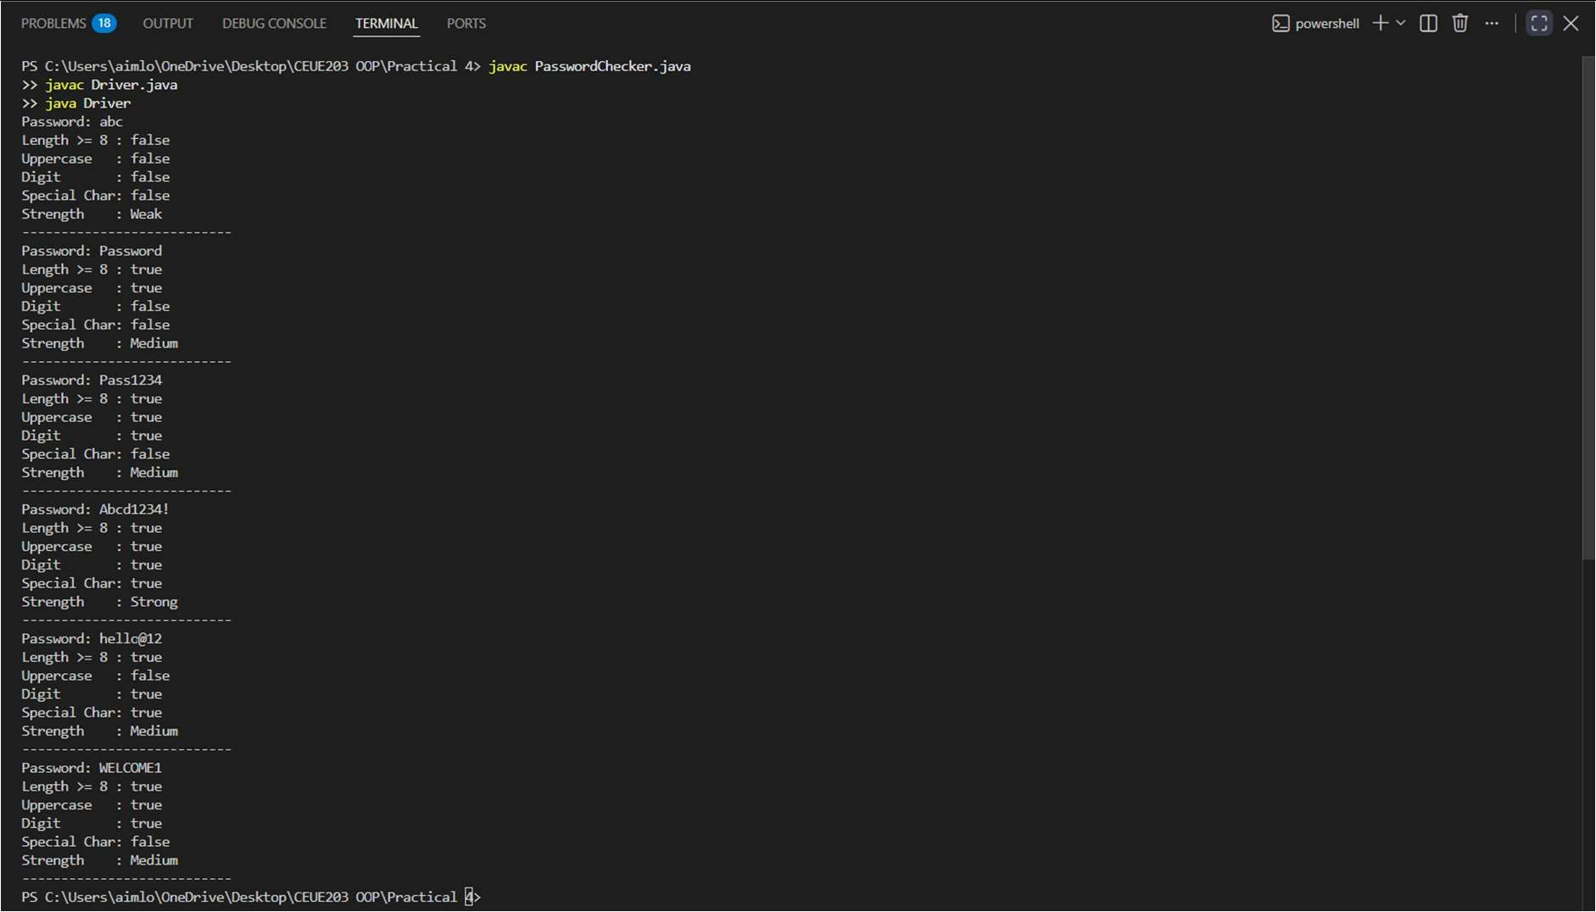
PROBLEM2 | - Chat-log Filter (ChatFilter.java + Driver.java)  - In Driver.main, define a String[] of log lines like "10:05 alice Hello there" (include one malformed line with fewer than 3 parts).  - Read a keyword from the user.  - For each line, split into time/user/message with split(" ", 3); skip lines that do not have 3 parts.  - If the message contains the keyword (case-insensitive), increment a counter and append "time user: message" to a StringBuilder.  - Print "Matches: N" and the built report.  Expected Output: Keyword "hello" over 3 lines (1 malformed) -> "Matches: 1" and the matching line.
CODE | public class ChatFilter {  public static String filterChats(String[] logs, String keyword) { StringBuilder result = new StringBuilder();  int count = 0;  for (String line : logs) {  String[] parts = line.split(" ", 3);

if (parts.length < 3) { continue;
}

String time = parts[0]; String user = parts[1]; String message = parts[2];

if (message.toLowerCase().contains(keyword.toLowerCase())) { count++;
result.append(time)
.append(" ")
.append(user)
.append(": ")
.append(message)
.append("\n");
}
}

return "Matches: " + count + "\n" + result.toString();
}
}

DRIVER CLASS

import java.util.Scanner; public class Driver1 {
public static void main(String[] args) {

String[] logs = {
"10:05 om Hello there", "10:10 bhavy How are you?", "10:15",
"10:20 manthan Good morning"
};

Scanner sc = new Scanner(System.in);

System.out.print("Enter keyword: "); String keyword = sc.nextLine();
String output = ChatFilter.filterChats(logs, keyword); System.out.println(output);

sc.close();
}
}
OUTPUT | 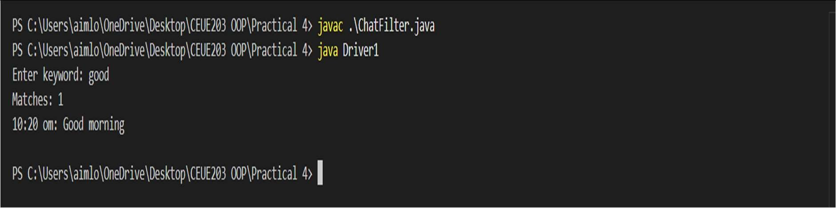
PROBLEM3 | 3. Template Filler (TemplateFiller.java + Driver.java)  - In Driver.main, define a template like "Dear {name}, order {id} ships {date}." and two parallel arrays: names {"name", "id"} and values {"Riya", "A07"} (note {date} is not supplied).  - Compile a Pattern for {(\w+)} and get a Matcher on the template.  - Walk the matches with a StringBuilder. For each {placeholder}, look up its value in the names array and replace it with the value, or with "[?]" if not found.  - Print the filled template.  Expected Output: The unsupplied {date} becomes [?].
CODE | import java.util.regex.*; public class TemplateFiller {  public static String fillTemplate(String template, String[] names, String[] values) {  Pattern p = Pattern.compile("\\{(\\w+)\\}"); Matcher m = p.matcher(template);  StringBuilder result = new StringBuilder(); int last = 0;  while (m.find()) {  result.append(template.substring(last, m.start())); String key = m.group(1);  String value = "[?]";  for (int i = 0; i < names.length; i++) {

if (names[i].equals(key)) { value = values[i]; break;
}
}

result.append(value); last = m.end();
}
result.append(template.substring(last)); return result.toString();
}
}

DRIVER CLASS

public class Driver2 {

public static void main(String[] args) {
String template = "Dear {name}, order {id} ships {date}."; String[] names = {"name", "id"};
String[] values = {"OM", "72"};
String output = TemplateFiller.fillTemplate(template, names, values); System.out.println(output);
}
}
OUTPUT | 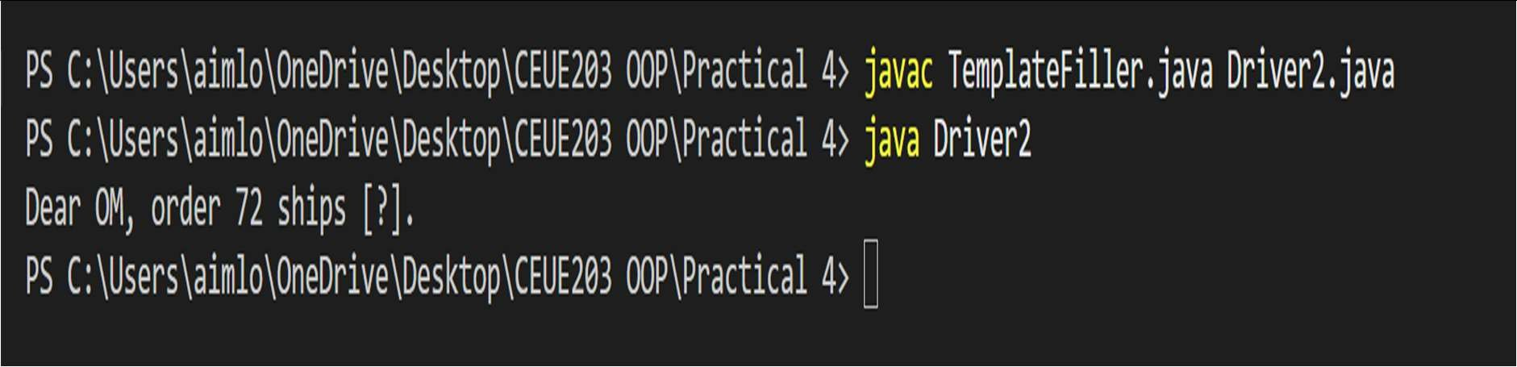

PRACTICAL - 05
Part A — Practice Programs (Hour 1)

PROBLEM1 | Shape areas: an abstract Shape with abstract area(); subclasses Circle, Rectangle, Triangle. Put a mix in a Shape[] and loop once to print each area and the running  total, tracking the largest — one loop handling every shape through polymorphism.
CODE | abstract class Shape {  public abstract double area();  }  class Circle extends Shape { private double radius;  public Circle(double radius) { this.radius = radius;  }  public double area() {  return Math.PI * radius * radius;  }  }  class Rectangle extends Shape { private double width, height;  public Rectangle(double width, double height) { this.width = width;  this.height = height;  }  public double area() { return width * height;  }  }  class Triangle extends Shape { private double base, height;

public Triangle(double base, double height) { this.base = base;
this.height = height;
}

public double area() { return 0.5 * base * height;
}
}

public class ShapeTest {

public static void main(String[] args) { Shape[] shapes = {
new Circle(5),
new Rectangle(3, 5),
new Triangle(4, 6),}; double totalArea = 0;
double largestArea = Double.MIN_VALUE; Shape largestShape = null;
for (Shape s : shapes) { double area = s.area();
System.out.println("Area: " + area); totalArea += area;

if (area > largestArea) { largestArea = area; largestShape = s;
}
}

System.out.println("Total area = " + totalArea); System.out.println("Largest area = " + largestArea + " (from " +
largestShape.getClass().getSimpleName() + ")");
}
}
OUTPUT | 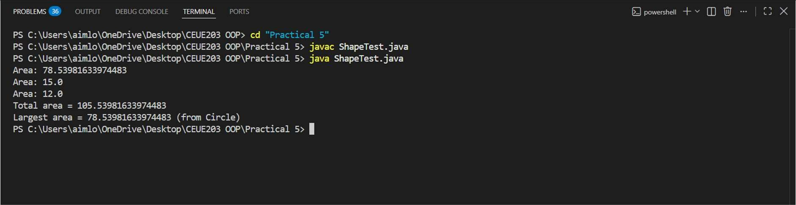

PROBLEM2 | Payroll: an abstract Employee with abstract monthlySalary(); FullTime (fixed), PartTime (hours × rate) and Intern (stipend), each calling super for the shared name/id. Loop a mixed array to print each salary and the total; use instanceof to add a note only for  interns.
CODE | abstract class Employee {  private String name; private int id;  public Employee(String name, int id) { this.name = name;  this.id = id;  }  public String getName() { return name;  }  public int getId() { return id;  }  public abstract double monthlySalary();  }  class FullTime extends Employee { private double salary;  public FullTime(String name, int id, double salary) { super(name, id);  this.salary = salary;  }  public double monthlySalary() { return salary;  }  }  class PartTime extends Employee {  private int hours; private double rate;

public PartTime(String name, int id, int hours, double rate) { super(name, id);
this.hours = hours; this.rate = rate;
}

public double monthlySalary() { return hours * rate;
}
}

class Intern extends Employee { private double stipend;
public Intern(String name, int id, double stipend) { super(name, id);
this.stipend = stipend;
}

public double monthlySalary() { return stipend;
}
}

public class PayrollTest {

public static void main(String[] args) { Employee[] employees = {
new FullTime("Om", 72, 500000),
new PartTime("Jugal", 65, 80, 200),
new Intern("Yug R", 62, 5000),
new FullTime("Yug T", 75, 60000),}; double total = 0;
for (Employee e : employees) { double salary = e.monthlySalary();
System.out.print(e.getName() + " (ID " + e.getId() + ") salary is " + salary); if (e instanceof Intern) {
System.out.print(" [Internship]");
}
System.out.println(); total += salary;
}

System.out.println("Total payroll = " + total);

}
}
OUTPUT | 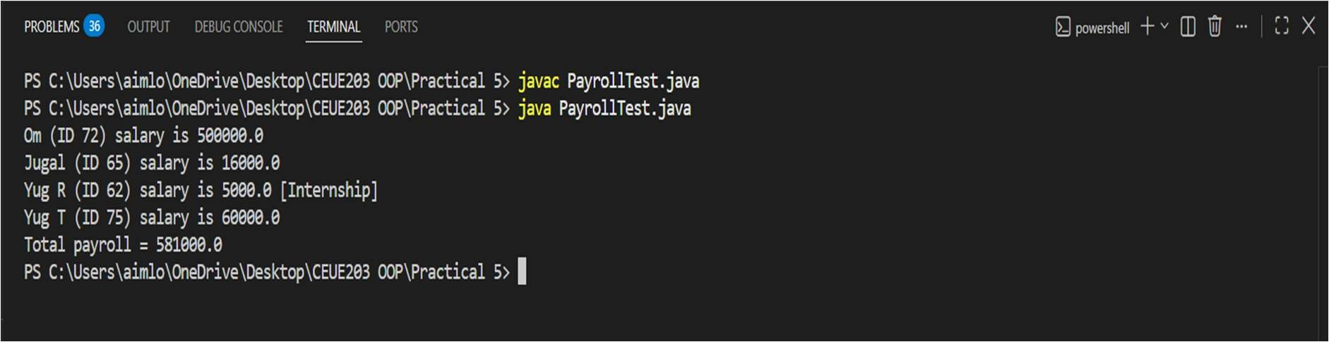
PROBLEM3 | (For Advanced Learners – home) Model a few media types that each compute a late fee differently and total the fees for a returned batch. Design the hierarchy and rules yourself.
CODE | abstract class Media { private String title; private int id;  public Media(String title, int id) { this.title = title;  this.id = id;  }  public String getTitle() { return title; } public int getId() { return id; }  public abstract double lateFee(int daysLate);  }  class Book extends Media { public Book(String title, int id) {  super(title, id);  }  @Override  public double lateFee(int daysLate) { return daysLate * 2.0;  }  }  class DVD extends Media { public DVD(String title, int id) {  super(title, id);  }

public double lateFee(int daysLate) { return daysLate * 5.0;
}
}

class Magazine extends Media { public Magazine(String title, int id) {
super(title, id);
}

public double lateFee(int daysLate) { return daysLate > 0 ? 10.0 : 0.0;
}
}

public class MediaTest {
public static void main(String[] args) { Media[] items = {
new Book("Java", 1),
new DVD("Inception", 2),
new Magazine("Weekly Magazine", 3), new Book("DSA in C++", 4),
new DVD("Interstellar", 5)
};

int[] daysLate = {3, 1, 0, 5, 2}; double totalFee = 0;

for (int i = 0; i < items.length; i++) {
double fee = items[i].lateFee(daysLate[i]); System.out.println(items[i].getTitle() + " (ID " + items[i].getId() +
") late fee = " + fee); totalFee += fee;
}

System.out.println("Total late fees = " + totalFee);
}
}

OUTPUT | 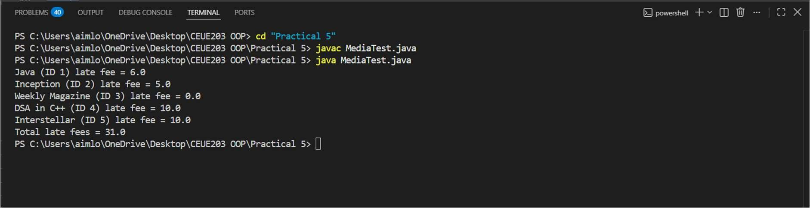

PRACTICAL - 06
Part A — Practice Programs (Hour 1)

PROBLEM1 | 1. Remote control: an interface Switchable with on()/off() and a default toggle(); Fan and Light implement it. Loop over a Switchable[] toggling each. Then add a functional interface that decides, given a device and an hour, whether it may switch on, and supply it  once as an anonymous class and once as a lambda.
CODE | interface Switchable { void on();  void off();  default void toggle() { on();  off();  }  }  class Fan implements Switchable { public void on() {  System.out.println("Fan is ON");  }  public void off() { System.out.println("Fan is OFF");  }  }  class Light implements Switchable { public void on() {  System.out.println("Light is ON");  }  public void off() { System.out.println("Light is OFF");  }  }  @FunctionalInterface interface Permission {  boolean maySwitchOn(String device, int hour);  }

public class RemoteControl {
public static void main(String[] args) { Fan fan = new Fan();
Light light = new Light();

Switchable[] devices = {fan, light};
System.out.println("Toggling devices:"); for (Switchable device : devices) {
device.toggle();
}

Permission p1 = new Permission() {
public boolean maySwitchOn(String device, int hour) { return hour >= 6 && hour <= 22;
}
};

System.out.println("Fan at 10: " + p1.maySwitchOn("Fan", 10)); System.out.println("Light at 2: " + p1.maySwitchOn("Light", 2));

Permission p2 = (device, hour) -> hour >= 6 && hour <= 22;

System.out.println("\nUsing lambda:"); System.out.println("Fan at 8: " + p2.maySwitchOn("Fan", 8)); System.out.println("Light at 3: " + p2.maySwitchOn("Light", 3));
}
}
OUTPUT | 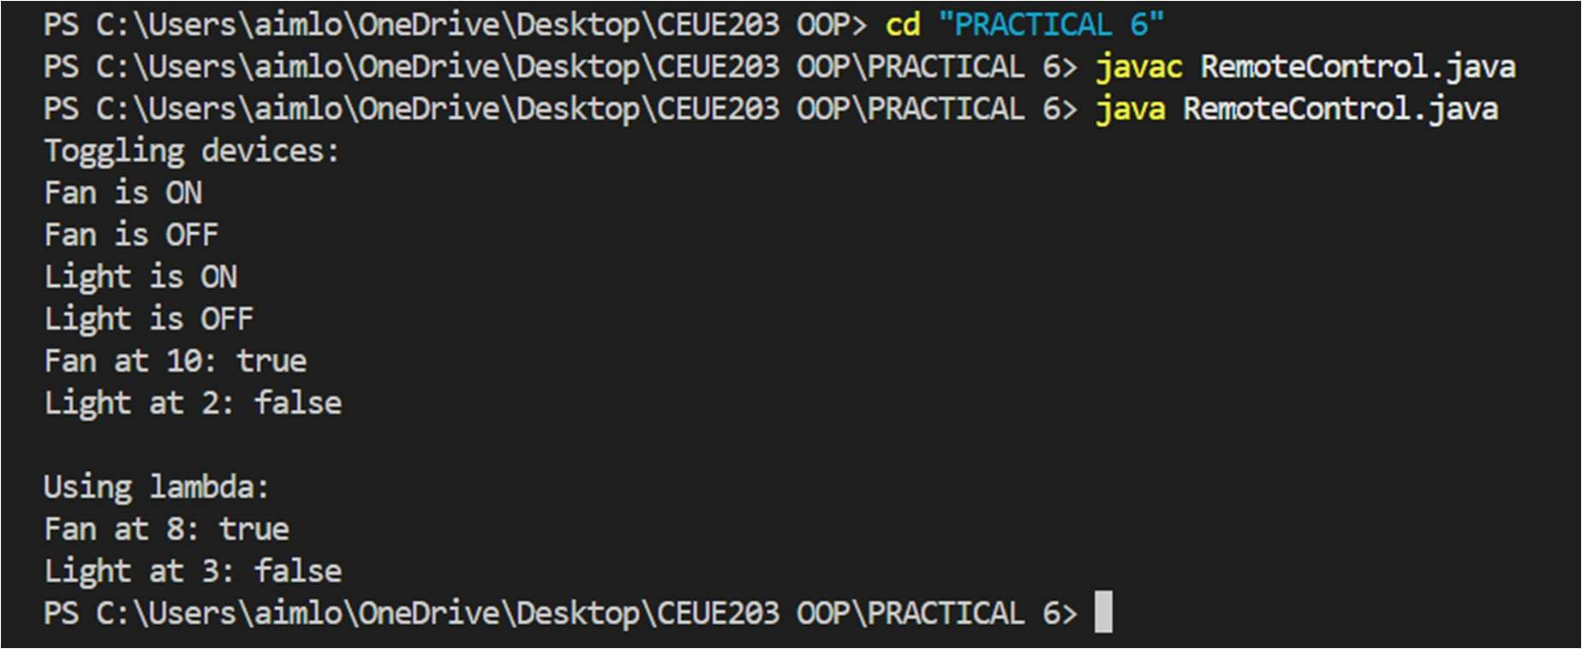

PROBLEM2 | 2. Notification senders: a functional interface Notifier with send (String); make email and SMS senders as lambdas, hold them in an array, and broadcast one message through all. Add a marker interface Urgent and send twice for senders marked urgent.
CODE | @FunctionalInterface interface Notifier {  void send(String message);  }  interface Urgent {  }  class Email implements Urgent { String name;  Email(String name) { this.name = name;  }  }  class SMS { String name;  SMS(String name) { this.name = name;  }  }  public class NotificationSender {  public static void main(String[] args) {  Email email = new Email("Email"); SMS sms = new SMS("SMS");  Notifier email_sender = message -> System.out.println("Email: " + message);  Notifier sms_sender = message -> System.out.println("SMS: " + message);  Notifier[] senders = {email_sender, sms_sender}; String message = "Meeting at 5 PM";  for (Notifier sender : senders) {  sender.send(message);

if (sender == email_sender && email instanceof Urgent) { sender.send(message);
}
}
}
}
OUTPUT | 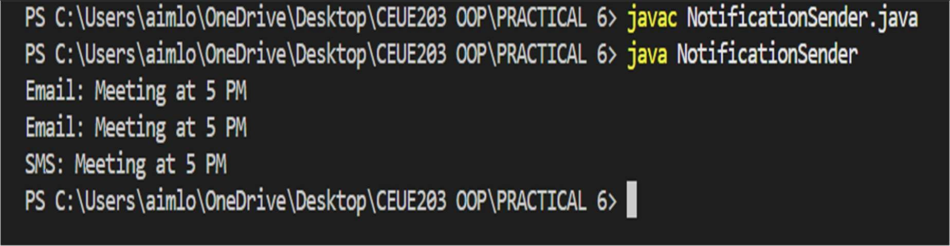
PROBLEM3 | 3. (For Advanced Learners – home) Build a small discount engine where each rule is a lambda the user picks at runtime and applies to a list of prices; organise it into packages and ship it as a runnable JAR.
CODE | DiscountApp.java  package discount; import java.util.Scanner;  public class DiscountApp {  public static void main(String[] args) { Scanner sc = new Scanner(System.in); double[] prices = {500, 1000, 1500, 2000};  System.out.println("Choose discount:"); System.out.println("1. 10% discount");  System.out.println("2. 20% discount");  System.out.println("3. 50% discount");  System.out.print("Enter choice: "); int choice = sc.nextInt();  DiscountRule rule; if (choice == 1) {  rule = price -> price - (price * 0.10);  }

else if (choice == 2) {
rule = price -> price - (price * 0.20);
}
else if (choice == 3) {
rule = price -> price - (price * 0.50);
}
else {
System.out.println("Invalid choice"); sc.close();
return;
}
System.out.println("\nPrices after discount:"); for (double price : prices) {
double final_price = rule.apply(price); System.out.println(price + " -> " + final_price);
}

sc.close();
}
}

DiscountRule.java
package discount; @FunctionalInterface
public interface DiscountRule { double apply(double price);
}
OUTPUT | 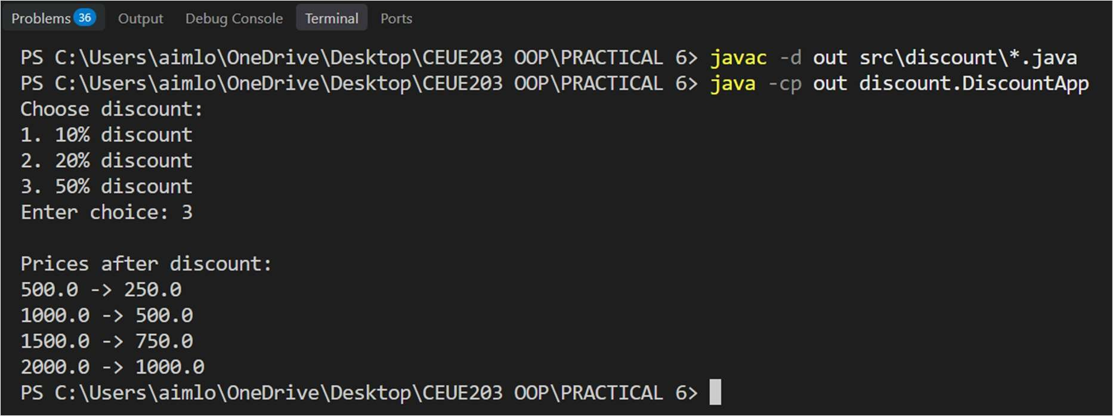

PRACTICAL - 06
Part A — Practice Programs (Hour 1)

PROBLEM1 | 1. Form validator: define @NotBlank and @MaxLength(int) for fields and annotate a SignupForm. Write a checker that uses reflection to read each field’s annotations and returns the list of validation errors for a given object.
CODE | import java.lang.annotation.*; import java.lang.reflect.Field; import java.util.*;  @Retention(RetentionPolicy.RUNTIME) @Target(ElementType.FIELD) @interface NotBlank {  }  @Retention(RetentionPolicy.RUNTIME) @Target(ElementType.FIELD) @interface MaxLength {  int value();  }  class SignupForm {  @NotBlank @MaxLength(10) String username;  @NotBlank @MaxLength(20) String email;  SignupForm(String username, String email) { this.username = username;  this.email = email;  }  }  public class Main {  public static void main(String[] args) throws Exception {  SignupForm form = new SignupForm("", "abcdefghijklmnop@gmail.com"); List<String> errors = new ArrayList<>();

for (Field field : form.getClass().getDeclaredFields()) { field.setAccessible(true);
String value = (String) field.get(form);

// Check NotBlank
if (field.isAnnotationPresent(NotBlank.class)) { if (value == null || value.trim().isEmpty()) {
errors.add(field.getName() + " cannot be blank");
}
}

// Check MaxLength
if (field.isAnnotationPresent(MaxLength.class)) {
MaxLength max = field.getAnnotation(MaxLength.class); if (value != null && value.length() > max.value()) {
errors.add(field.getName()
+ " is too long. Maximum "
+ max.value() + " characters allowed");
}
}
}

if (errors.isEmpty()) { System.out.println("Form is valid");
} else {
for (String error : errors) { System.out.println(error);
}
}
}
}
OUTPUT | 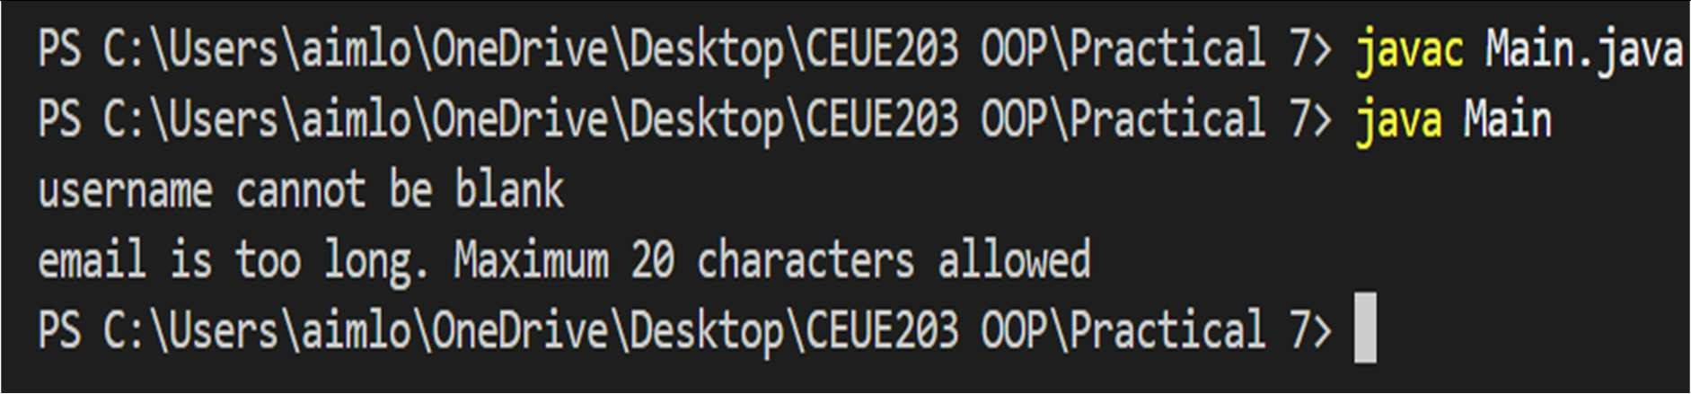

PROBLEM2 | 2. Mini test runner: define a @Run annotation and mark some no-arg methods of a class with it. Use reflection to find and invoke only the @Run methods and report how many ran  — the idea behind how JUnit finds @Test methods.
CODE | import java.lang.annotation.*; import java.lang.reflect.Method;  @Retention(RetentionPolicy.RUNTIME) @Target(ElementType.METHOD) @interface Run {  }  class MyTests { @Run  public void test1() { System.out.println("Test 1 executed");  }  @Run  public void test2() { System.out.println("Test 2 executed");  }  public void normalMethod() { System.out.println("Normal method");  }  }  public class Mini {  public static void main(String[] args) throws Exception { MyTests obj = new MyTests();  int count = 0;  Method[] methods = obj.getClass().getDeclaredMethods(); for (Method method : methods) {  if (method.isAnnotationPresent(Run.class) && method.getParameterCount() == 0) {  method.invoke(obj); count++;  }  }

System.out.println("Total methods executed: " + count);
}
}
OUTPUT | 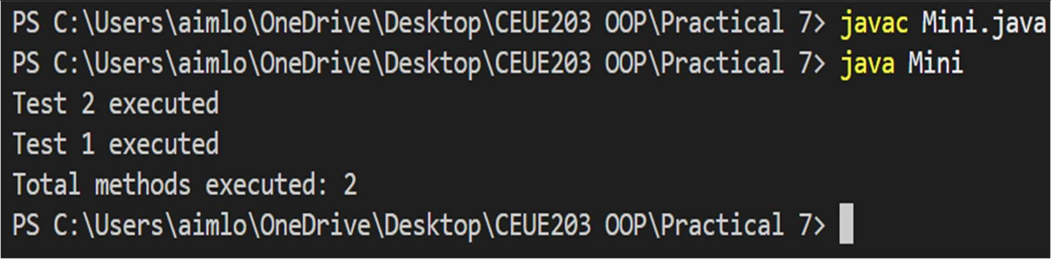
PROBLEM3 | 3. (For Advanced Learners – home) Define a @Column(name) annotation and, by reflection, populate an object’s fields from a header row and a data row by matching column names; decide how to handle a missing column.
CODE | import java.lang.annotation.*; import java.lang.reflect.Field;  @Retention(RetentionPolicy.RUNTIME) @Target(ElementType.FIELD) @interface Column {  String name();  }  class Student {  @Column(name = "id") String id;  @Column(name = "name") String name;  @Column(name = "email") String email;  }  public class Columns {  public static void main(String[] args) throws Exception { String[] headers = {"id", "name", "email"};  String[] data = {"101", "Om", "om@gmail.com"};

Student student = new Student();

Field[] fields = student.getClass().getDeclaredFields(); for (Field field : fields) {
if (field.isAnnotationPresent(Column.class)) {

Column column = field.getAnnotation(Column.class); for (int i = 0; i < headers.length; i++) {
if (headers[i].equals(column.name())) {

field.setAccessible(true); field.set(student, data[i]);

break;
}
}
}
}

System.out.println("ID: " + student.id); System.out.println("Name: " + student.name); System.out.println("Email: " + student.email);
}
}
OUTPUT | 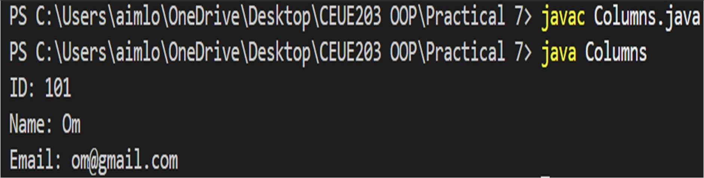

PRACTICAL - 08
Part A — Practice Programs (Hour 1)

PROBLEM1 | 1. Guarded calculator: read two numbers and an operator; throw a custom DivideByZeroException and catch invalid-number input separately, printing a clear message each time; loop until a valid calculation succeeds and use finally to log each  attempt.
CODE | import java.util.Scanner; public class Calculator {  public static void main(String[] args) { Scanner sc = new Scanner(System.in);  try {  System.out.print("Enter first number: "); double num1 = sc.nextDouble();  System.out.print("Enter second number: "); double num2 = sc.nextDouble();  if (num1 < 0 || num2 < 0) {  throw new InvalidNumberException("Negative numbers are not allowed!");  }  if(num1==0 || num2==0){  throw new InvalidNumberException("Multiplication By Zero is not allowed!");  }  System.out.print("Enter operator (+, -, *, /): "); char op = sc.next().charAt(0);  System.out.println("You entered: " + num1 + " " + op + " " + num2); double result = 0;  if (op == '+') {  result = num1 + num2;  } else if (op == '-') { result = num1 - num2;  } else if (op == '*') { result = num1 * num2;  } else if (op == '/') { if (num2 == 0) {  throw new DivideByZeroException("Cannot divide by zero!");

}
result = num1 / num2;
} else {
throw new InvalidNumberException("Invalid operator entered!");
}

System.out.println(num1 + " " + op + " " + num2 + " = " + result);

} catch (DivideByZeroException e) { System.out.println("Error: " + e.getMessage());
} catch (InvalidNumberException e) { System.out.println("Error: " + e.getMessage());
} catch (Exception e) {
System.out.println("Unexpected error: " + e.getMessage());
} finally {
System.out.println("Exiting the program."); sc.close();
}
}
}
class DivideByZeroException extends Exception { public DivideByZeroException(String message) {
super(message);
}
}
class InvalidNumberException extends Exception { public InvalidNumberException(String message) {
super(message);
}
}
OUTPUT | 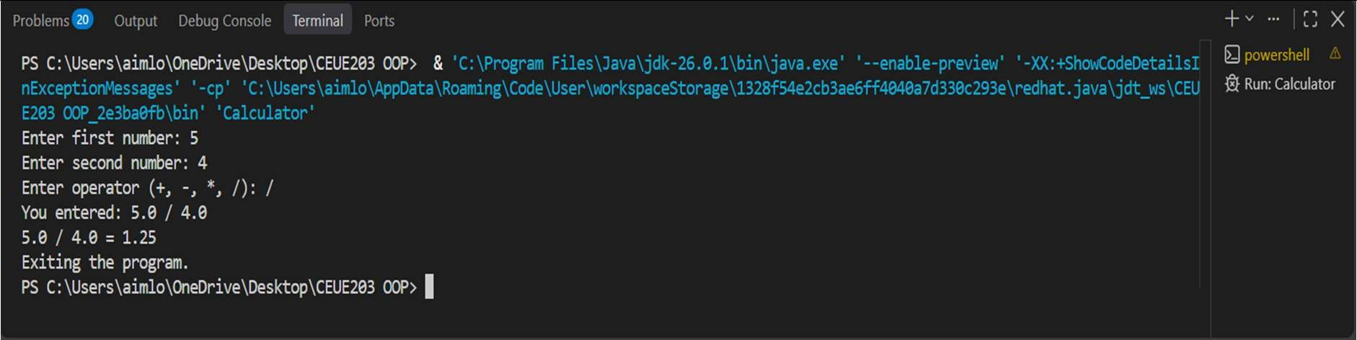

PROBLEM2 | 2. Stock issue: a Warehouse where issue(item, qty) throws a custom checked OutOfStockException carrying the shortfall, and InvalidQuantityException for qty ≤ 0. Process a list of requests, catching and reporting each failure without stopping the run.
CODE | import java.util.Scanner;  class outofstockexception extends Exception { private int shortage;  public outofstockexception(int shortage) { super("out of stock! shortage: " + shortage); this.shortage = shortage;  }  public int getshortage() { return shortage;  }  }  class invalidquantityexception extends Exception { public invalidquantityexception() {  super("invalid quantity! must be greater than 0.");  }  }  class store { private int stock;  public store(int stock) { this.stock = stock;  }  public void issue(String item, int qty)  throws outofstockexception, invalidquantityexception {  if (qty <= 0) {  throw new invalidquantityexception();  }  if (qty > stock) {  int shortage = qty - stock;  throw new outofstockexception(shortage);  }

stock -= qty;

System.out.println("issued: " + qty + " " + item); System.out.println("left in stock: " + stock);
}
}

public class storemanagement {

public static void main(String[] args) { Scanner sc = new Scanner(System.in);

System.out.print("enter starting stock: "); int stock = sc.nextInt();

store s = new store(stock);

System.out.print("enter number of requests: "); int requests = sc.nextInt();
sc.nextLine();

for (int i = 1; i <= requests; i++) { System.out.println("\nrequest " + i);

System.out.print("enter item name: "); String item = sc.nextLine();

System.out.print("enter quantity: "); int qty = sc.nextInt();
sc.nextLine();

try {
s.issue(item, qty);
} catch (outofstockexception e) { System.out.println("error: " + e.getMessage());
} catch (invalidquantityexception e) { System.out.println("error: " + e.getMessage());
}
}

sc.close();
}
}

OUTPUT | 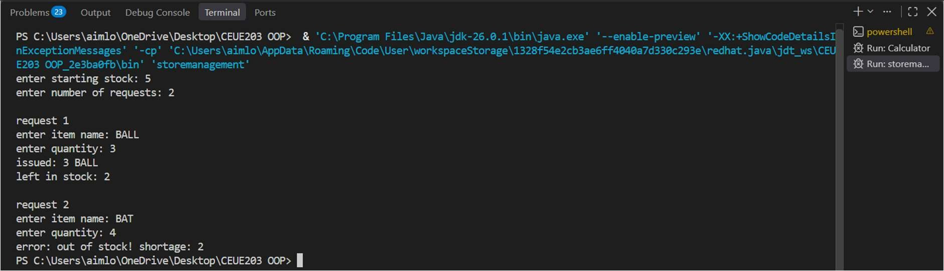
PROBLEM3 | 3. (For Advanced Learners – home) Create an AutoCloseable resource and use try-with-resources to prove it always closes — even when an exception is thrown inside the block  — and that the original error is the one reported. Decide what to model as the resource.
CODE | class MyResource implements AutoCloseable {  void doWork() {  System.out.println("Resource is doing some work..."); throw new RuntimeException("Original error occurred");  }  @Override  public void close() { System.out.println("Resource is closed");  throw new RuntimeException("Error while closing resource");  }  }  public class Main {  public static void main(String[] args) {  try (MyResource resource = new MyResource()) {  System.out.println("Resource is opened"); resource.doWork();  } catch (Exception e) {  System.out.println("Main error: " + e.getMessage()); for (Throwable error : e.getSuppressed()) {  System.out.println("Suppressed error: " + error.getMessage());  }  }  }  }

OUTPUT | 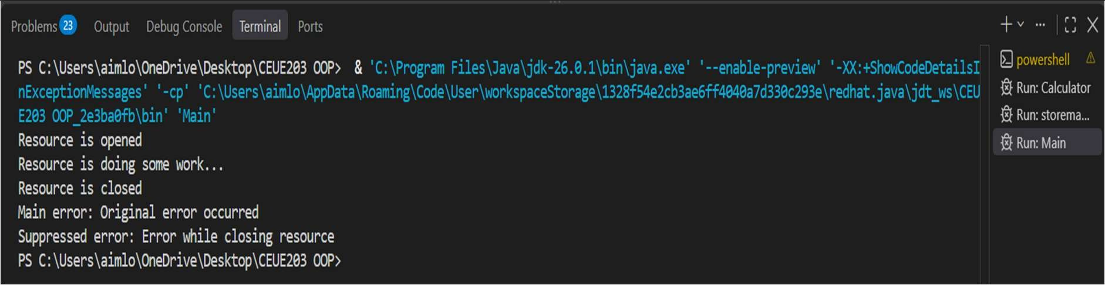

PRACTICAL - 0G
Part A — Practice Programs (Hour 1)

PROBLEM1 | 1. Counter race: several threads each increment a shared counter many times. Run it without synchronization to watch the total come out too low, then make the increment synchronized and confirm it is exactly right every run.
CODE | class Counter { int count = 0;  void increment() { count++;  }  }  class CounterThread extends Thread { Counter counter;  int times;  CounterThread(Counter counter, int times) { this.counter = counter;  this.times = times;  }  public void run() {  for (int i = 0; i < times; i++) { counter.increment();  }  }  }  public class CounterRace {  public static void main(String[] args) throws Exception { int threadCount = 10;  int times = 100000;  // Without synchronization Counter counter = new Counter();  Thread[] threads = new Thread[threadCount];  for (int i = 0; i < threadCount; i++) {  threads[i] = new CounterThread(counter, times); threads[i].start();  }

for (Thread thread : threads) { thread.join();
}

System.out.println("Without synchronization: " + counter.count); System.out.println("Expected: " + (threadCount * times));

// With synchronization
Counter counter2 = new Counter();
Thread[] threads2 = new Thread[threadCount]; for (int i = 0; i < threadCount; i++) {
threads2[i] = new Thread(() -> { for (int j = 0; j < times; j++) {

synchronized (counter2) { counter2.count++;
}

}
});

threads2[i].start();
}

for (Thread thread : threads2) { thread.join();
}

System.out.println("With synchronization: " + counter2.count); System.out.println("Expected: " + (threadCount * times));
}
}
OUTPUT | 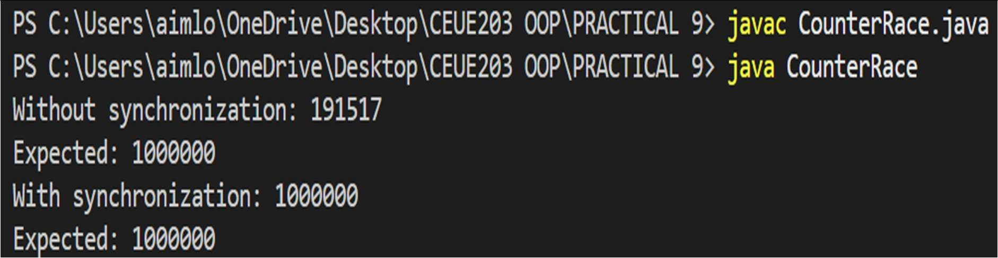

PROBLEM2 | 2. Seat booking race: a shared seatsLeft of 5 with about 10 threads each trying to book one seat. Without synchronization show that more than 5 can succeed (oversell); with a synchronized book() exactly 5 do.
CODE | class SeatBooking { int seatsLeft = 5;  void book() {  if (seatsLeft > 0) { try {  Thread.sleep(10);  } catch (InterruptedException e) { e.printStackTrace();  }  seatsLeft--; System.out.println(Thread.currentThread().getName()  + " booked a seat.");  } else {  System.out.println(Thread.currentThread().getName()  + " failed - No seats left.");  }  }  synchronized void bookSynchronized() { if (seatsLeft > 0) {  try {  Thread.sleep(10);  } catch (InterruptedException e) { e.printStackTrace();  }  seatsLeft--; System.out.println(Thread.currentThread().getName()  + " booked a seat.");  } else {  System.out.println(Thread.currentThread().getName()  + " failed - No seats left.");  }  }  }  public class SeatBookingRace {  public static void main(String[] args) throws Exception {  // Without synchronization  SeatBooking booking = new SeatBooking();

 |  |  | Thread[] threads = new Thread[10];
 |  |  | System.out.println("WITHOUT SYNCHRONIZATION:");
for (int i = 0; i < 10; i++) { threads[i] = new Thread(
() -> booking.book(),
"Thread-" + (i + 1)
);
threads[i].start();
}
for (Thread thread : threads) { thread.join();
}
 |  |  | System.out.println("Seats left: " + booking.seatsLeft);
// With synchronization
SeatBooking booking2 = new SeatBooking();
 |  |  | Thread[] threads2 = new Thread[10];
 |  |  | System.out.println("\nWITH SYNCHRONIZATION:");
for (int i = 0; i < 10; i++) { threads2[i] = new Thread(
() -> booking2.bookSynchronized(), "Thread-" + (i + 1)
);
threads2[i].start();
}
for (Thread thread : threads2) { thread.join();
}
 | } | } | System.out.println("Seats left: " + booking2.seatsLeft);

OUTPUT | 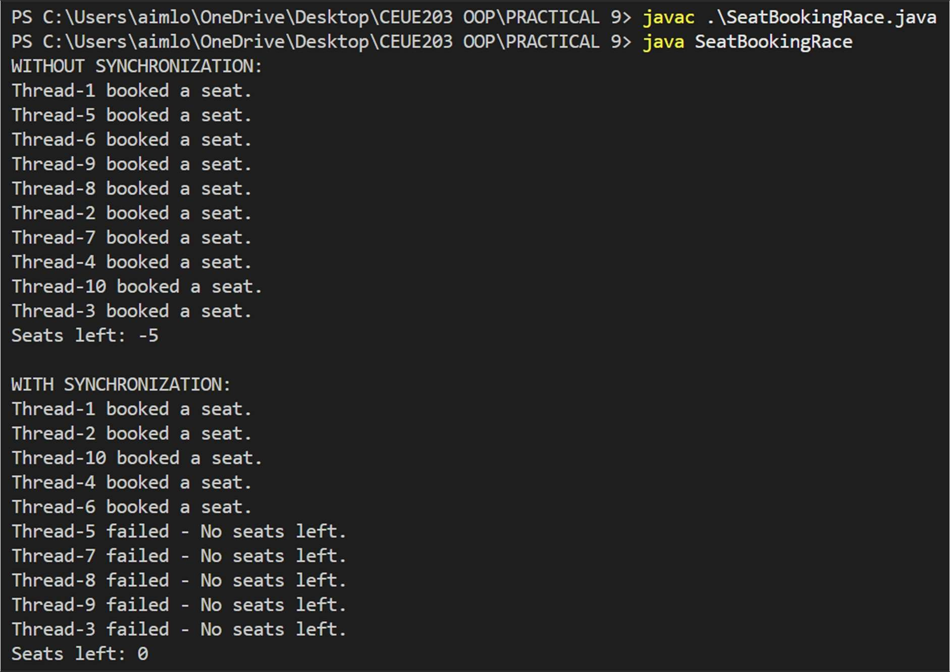
PROBLEM3 | 3. (For Advanced Learners – home) Split a large array of numbers across several threads that add into one shared total, show the wrong result, then fix it two ways and compare; decide how to measure the difference.
CODE | import java.util.concurrent.atomic.AtomicLong;  class SharedTotal { long total = 0;  void add(long value) { total += value;  }  synchronized void addSynchronized(long value) { total += value;  }  }  public class ArraySumRace {  static int[] arr = new int[1_000_000]; static int threadCount = 10;  public static void main(String[] args) throws Exception {  // Fill array with 1

for (int i = 0; i < arr.length; i++) { arr[i] = 1;
}

System.out.println("Expected Total: " + arr.length);

// 1. Without Synchronization SharedTotal total1 = new SharedTotal();
long start1 = System.nanoTime(); runThreads((start, end) -> {
for (int i = start; i < end; i++) {
total1.add(arr[i]);
}
});

long end1 = System.nanoTime();

System.out.println("\nWithout Synchronization:"); System.out.println("Total = " + total1.total);
System.out.println("Time = " + (end1 - start1) / 1_000_000.0 + " ms");

// 2. With Synchronization
SharedTotal total2 = new SharedTotal(); long start2 = System.nanoTime();
runThreads((start, end) -> {
for (int i = start; i < end; i++) { total2.addSynchronized(arr[i]);
}
});

long end2 = System.nanoTime();

System.out.println("\nWith Synchronization:"); System.out.println("Total = " + total2.total);
System.out.println("Time = " + (end2 - start2) / 1_000_000.0 + " ms");

// 3. Using AtomicLong
AtomicLong total3 = new AtomicLong(0);

long start3 = System.nanoTime();

runThreads((start, end) -> {
for (int i = start; i < end; i++) { total3.addAndGet(arr[i]);
}
});
 |  | long end3 = System.nanoTime();
System.out.println("\nUsing AtomicLong:"); System.out.println("Total = " + total3.get());
System.out.println("Time = " + (end3 - start3) / 1_000_000.0 + " ms");
}
interface Task {
void execute(int start, int end);
}
 |  | static void runThreads(Task task) throws Exception {
 |  | Thread[] threads = new Thread[threadCount];
 |  | int partSize = arr.length / threadCount;
 |  | for (int i = 0; i < threadCount; i++) {
 |  | int start = i * partSize;
int end = (i == threadCount - 1)
? arr.length
: start + partSize;
 |  | threads[i] = new Thread(() -> task.execute(start, end));
threads[i].start();
}
 | } | for (Thread thread : threads) { thread.join();  }  }

OUTPUT | 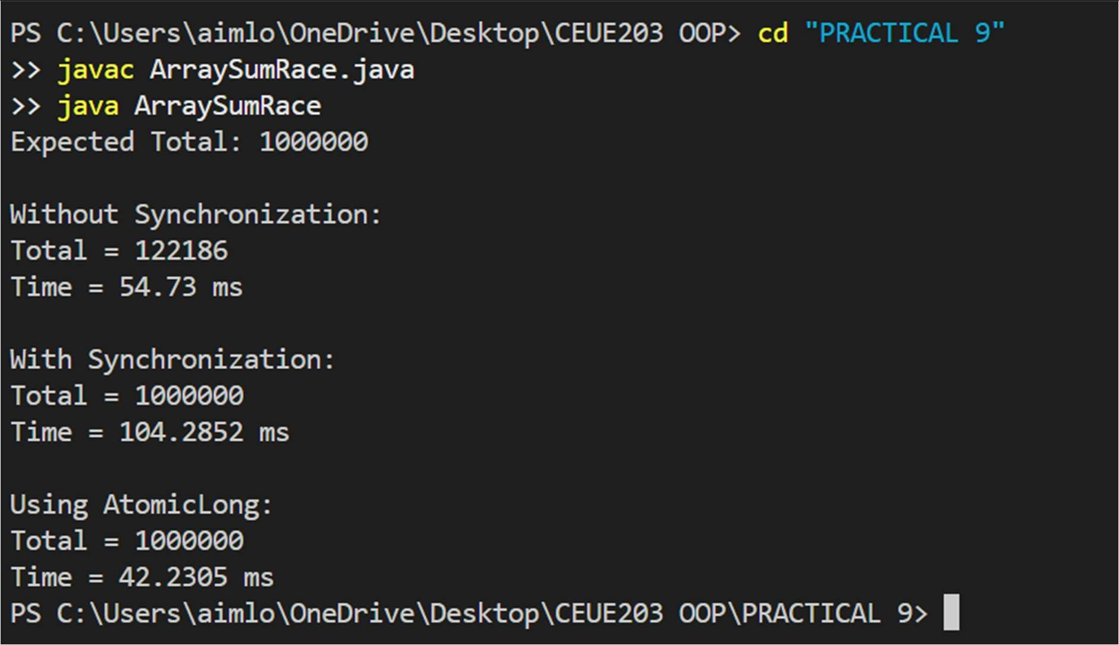

PRACTICAL - 10
Part A — Practice Programs (Hour 1)

PROBLEM1 | 1. Counter race: several threads each increment a shared counter many times. Run it without synchronization to watch the total come out too low, then make the increment synchronized and confirm it is exactly right every run.
CODE | import java.util.concurrent.ExecutorService; import java.util.concurrent.Executors; import java.util.concurrent.TimeUnit;  public class ThreadPoolRunner {  public static void main(String[] args) {  // Create a fixed thread pool with 3 threads  ExecutorService executor = Executors.newFixedThreadPool(3);  // Submit 10 tasks  for (int i = 1; i <= 10; i++) { int taskId = i;  executor.submit(() -> { try {  System.out.println(  "Task " + taskId + " is running on " + Thread.currentThread().getName()  );  // Sleep briefly Thread.sleep(1000);  System.out.println(  "Task " + taskId + " completed by " + Thread.currentThread().getName()  );  } catch (InterruptedException e) { Thread.currentThread().interrupt();  }  });  }  // No more tasks will be submitted executor.shutdown();

try {
// Wait until all tasks are completed
if (executor.awaitTermination(30, TimeUnit.SECONDS)) { System.out.println("All tasks completed.");
} else {
System.out.println("Timeout! Some tasks are still running.");
}
} catch (InterruptedException e) { Thread.currentThread().interrupt();
}
}
}
OUTPUT | 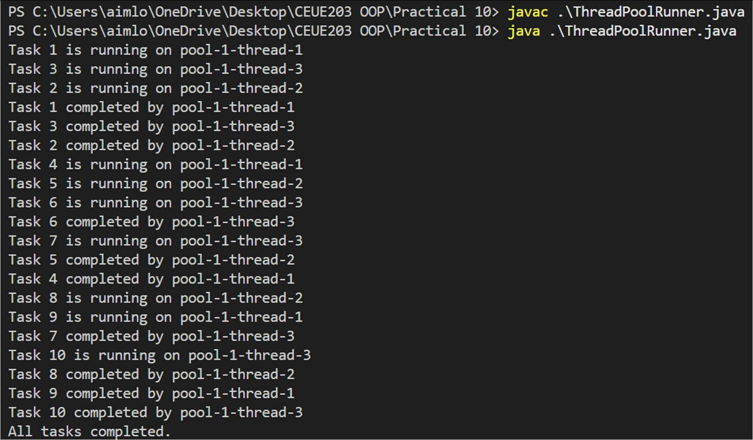
PROBLEM2 | 2. Producer–consumer: one thread adds numbers to a small shared buffer and another removes them, coordinated with wait()/notify(); produce and consume a fixed number of items in order with none lost.
CODE | class SharedBuffer {  private int item;  private boolean available = false;  // Producer adds an item  public synchronized void produce(int value) throws InterruptedException {  // Wait if buffer is full while (available) {  wait();  }

item = value; available = true;

System.out.println("Produced: " + value);

// Notify consumer notify();
}

// Consumer removes an item
public synchronized int consume() throws InterruptedException {

// Wait if buffer is empty while (!available) {
wait();
}

int value = item; available = false;

System.out.println("Consumed: " + value);

// Notify producer notify();

return value;
}
}

public class ProducerConsumer {

public static void main(String[] args) { SharedBuffer buffer = new SharedBuffer(); int numberOfItems = 10;
// Producer thread
Thread producer = new Thread(() -> { try {
for (int i = 1; i <= numberOfItems; i++) { buffer.produce(i);
Thread.sleep(200);
}
} catch (InterruptedException e) { Thread.currentThread().interrupt();
}

 |  |  | });
// Consumer thread
Thread consumer = new Thread(() -> { try {
for (int i = 1; i <= numberOfItems; i++) { buffer.consume(); Thread.sleep(300);
}
} catch (InterruptedException e) { Thread.currentThread().interrupt();
}
});
 |  |  | producer.start(); consumer.start();
try {
producer.join(); consumer.join();
} catch (InterruptedException e) { Thread.currentThread().interrupt();
}
 | } | } | System.out.println("All items produced and consumed.");
OUTPUT | 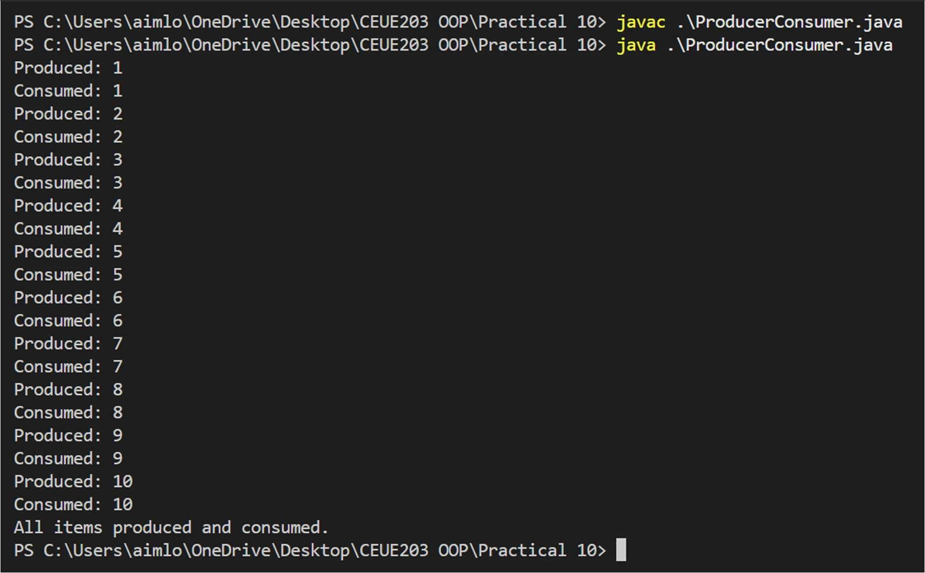

PROBLEM3 | 3. (For Advanced Learners – home) Reproduce a deadlock between two threads that lock two objects in opposite order, then remove it with a consistent lock order. Choose the scenario yourself.
CODE | public class DeadlockDemo {  static Object accountA = new Object(); static Object accountB = new Object();  // This method can cause DEADLOCK static void transferAtoB() {  synchronized (accountA) { System.out.println("Thread 1 locked Account A");  try {  Thread.sleep(100);  } catch (InterruptedException e) { Thread.currentThread().interrupt();  }  synchronized (accountB) { System.out.println("Thread 1 locked Account B");  }  }  }  // Locks objects in the OPPOSITE order static void transferBtoA() {  synchronized (accountB) { System.out.println("Thread 2 locked Account B");  try {  Thread.sleep(100);  } catch (InterruptedException e) { Thread.currentThread().interrupt();  }  synchronized (accountA) { System.out.println("Thread 2 locked Account A");  }  }  }  public static void main(String[] args) {

Thread thread1 = new Thread(DeadlockDemo::transferAtoB); Thread thread2 = new Thread(DeadlockDemo::transferBtoA);

thread1.start(); thread2.start();
}
}
OUTPUT | 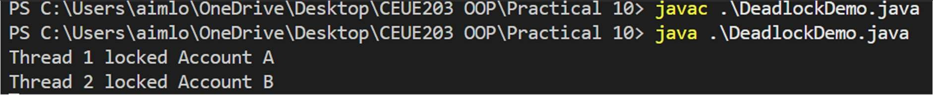

PRACTICAL - 11
Part A — Practice Programs (Hour 1)

PROBLEM1 | 1. Save/load: make a small class Serializable, save an array of its objects to a file with Object Output Stream, then read it back into fresh objects and confirm the values survived. Mark one field transient and show it is not saved.
CODE | import java.io.*;  class Student implements Serializable {  private static final long serialVersionUID = 1L; int rollNo;  String name;  // This field will NOT be saved transient String password;  Student(int rollNo, String name, String password) { this.rollNo = rollNo;  this.name = name; this.password = password;  }  void display() { System.out.println(  "Roll No: " + rollNo + ", Name: " + name +  ", Password: " + password  );  }  }  public class SaveLoad {  public static void main(String[] args) { Student[] students = {  new Student(1, "Om", "om123"), new Student(2, "Rahul", "rahul123"), new Student(3, "Amit", "amit123")  };  // Save objects  try (ObjectOutputStream out =

new ObjectOutputStream(
new FileOutputStream("students.dat"))) { out.writeObject(students); System.out.println("Students saved successfully.");
} catch (IOException e) { e.printStackTrace();
}

// Load objects
try (ObjectInputStream in = new ObjectInputStream(
new FileInputStream("students.dat"))) { Student[] loadedStudents = (Student[]) in.readObject(); System.out.println("\nStudents loaded from file:");
for (Student s : loadedStudents) { s.display();
}

} catch (IOException | ClassNotFoundException e) { e.printStackTrace();
}
}
}
OUTPUT | 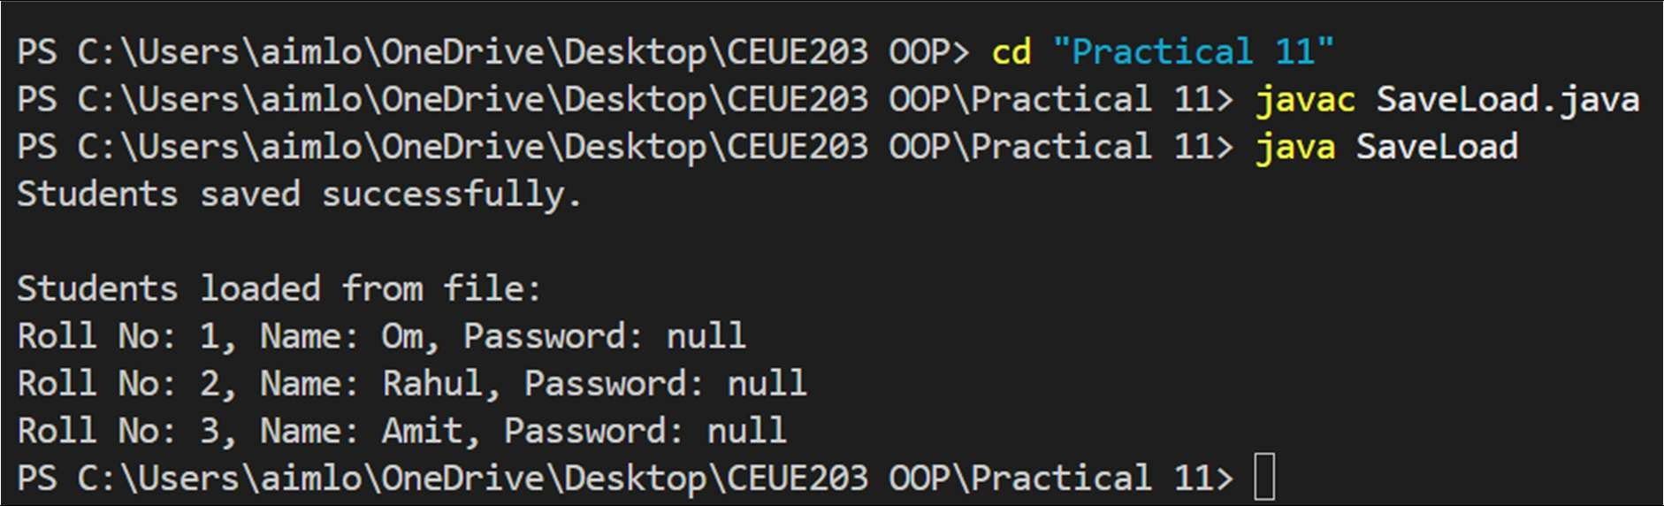
PROBLEM2 | 2. Log analyzer: create a few text files, then use Path/Files to read each line by line and count the total lines and how many contain a keyword across all files; also print each file’s size from its attributes.

CODE | import java.io.IOException; import java.nio.file.*; import java.util.List;  public class LogAnalyzer {  public static void main(String[] args) { String keyword = "ERROR";  Path[] files = { Paths.get("log1.txt"),  Paths.get("log2.txt"), Paths.get("log3.txt")  };  int totalLines = 0;  int keywordLines = 0; try {  for (Path file : files) {  // Get file size  long size = Files.size(file);  System.out.println("\nFile: " + file.getFileName()); System.out.println("Size: " + size + " bytes");  // Read file line by line  List<String> lines = Files.readAllLines(file); for (String line : lines) {  totalLines++;  if (line.contains(keyword)) { keywordLines++;  }  }  }  System.out.println("\n----- SUMMARY ");  System.out.println("Total lines: " + totalLines); System.out.println(  "Lines containing '" + keyword + "': "  + keywordLines

);

} catch (IOException e) { e.printStackTrace();
}
}
}
OUTPUT | 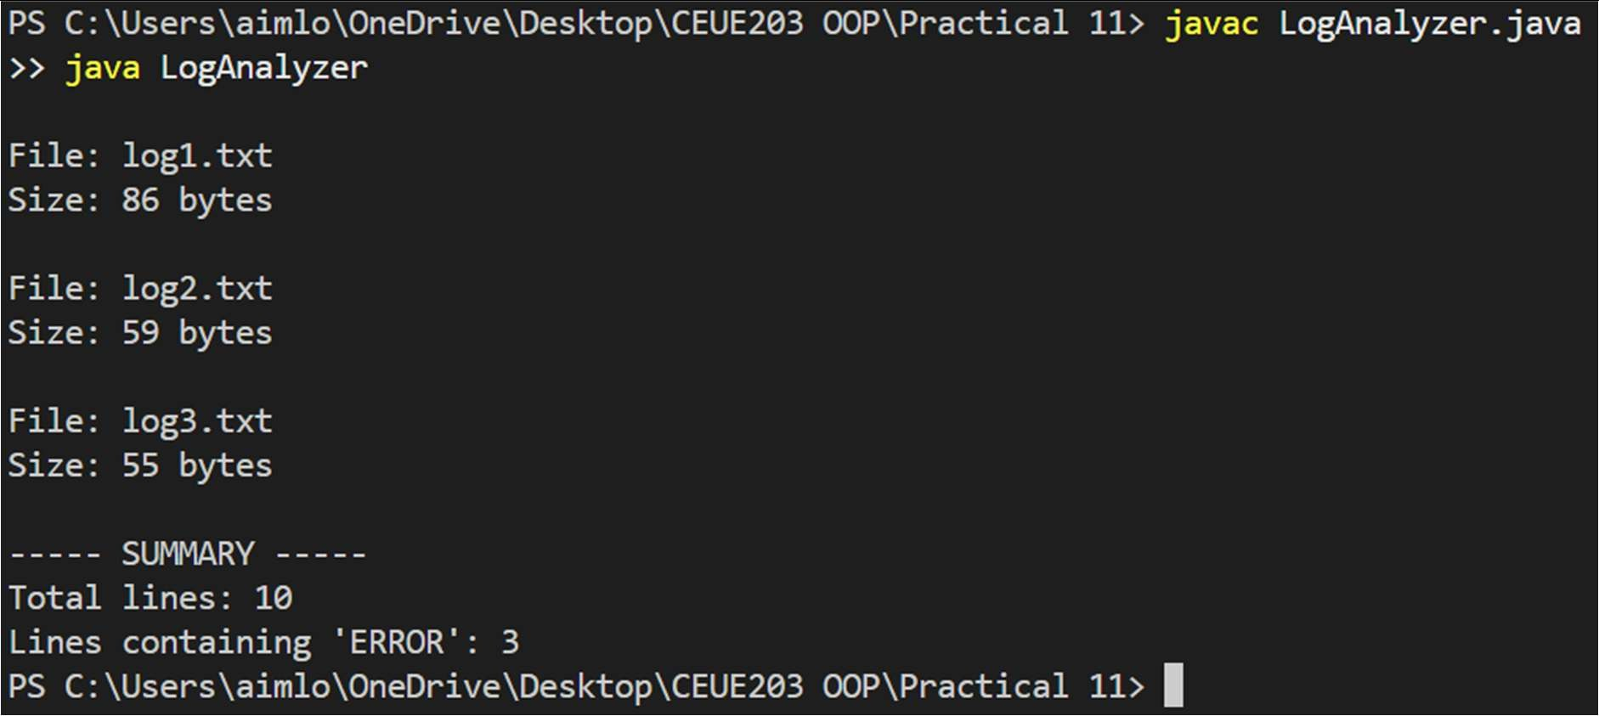
PROBLEM3 | 3. (For Advanced Learners – home) Walk a folder tree with NIO and produce a report of the files it contains (name, size, modified time), writing the summary to a file; decide what to include.
CODE | import java.io.IOException; import java.nio.file.*;  import java.nio.file.attribute.BasicFileAttributes; import java.util.stream.Stream;  public class FolderReport {  public static void main(String[] args) { Path folder = Paths.get("myfolder");  Path report = Paths.get("folder_report.txt");  try {  try (Stream<Path> paths = Files.walk(folder)) { StringBuilder result = new StringBuilder();  result.append("FOLDER REPORT\n"); result.append("====================\n\n");

paths.filter(Files::isRegularFile)
.forEach(path -> { try {
BasicFileAttributes attributes = Files.readAttributes(
path, BasicFileAttributes.class
);

result.append( "File Name: "
+ path.getFileName()
+ "\n"
);

result.append( "Path: "
+ path
+ "\n"
);

result.append( "Size: "
+ attributes.size()
+ " bytes\n"
);

result.append( "Modified: "
+ attributes.lastModifiedTime()
+ "\n"
);

result.append(
" \n"
);

} catch (IOException e) { System.out.println(
"Could not read: " + path
);
}
});

Files.writeString(report, result.toString());

}

System.out.println(
"Folder report created successfully."
);

} catch (IOException e) { e.printStackTrace();
}
}
}
OUTPUT | 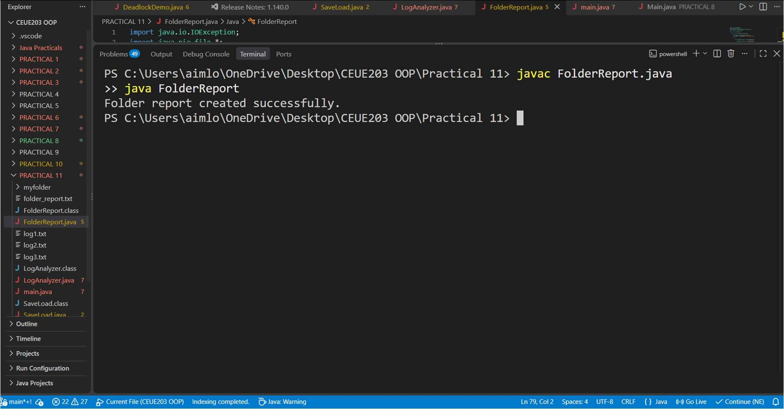

PRACTICAL - 12
Part A — Practice Programs (Hour 1)

PROBLEM1 | 1. Word frequency: split a paragraph into words, count each in a HashMap, and print the words sorted by frequency (highest first) using a Comparator.
CODE | import java.util.*;  public class WordFrequency {  public static void main(String[] args) {  String paragraph = "java is easy and java is powerful and java is popular"; HashMap<String, Integer> map = new HashMap<>();  String[] words = paragraph.toLowerCase().split("\\s+");  // Count frequency  for (String word : words) {  map.put(word, map.getOrDefault(word, 0) + 1);  }  // Sort by frequency (highest first) List<Map.Entry<String, Integer>> list =  new ArrayList<>(map.entrySet());  list.sort((a, b) -> b.getValue().compareTo(a.getValue()));  // Print result  System.out.println("Words sorted by frequency:");  for (Map.Entry<String, Integer> entry : list) { System.out.println(entry.getKey() + " : " + entry.getValue());  }  }  }

OUTPUT | 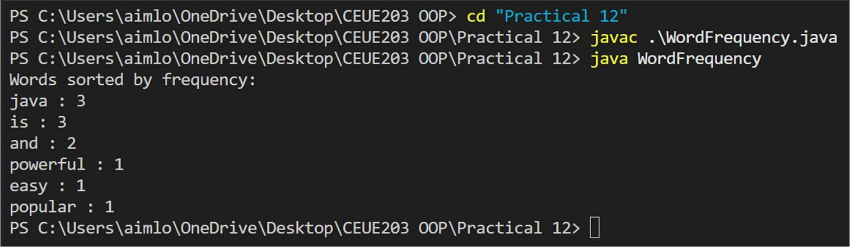
PROBLEM2 | 2. Unique visitors: from a list of login names with repeats, use a HashSet to count unique users and a LinkedHashSet to keep first-seen order; print the unique count and the first three distinct names.
CODE | import java.util.*;  public class UniqueVisitors {  public static void main(String[] args) {  List<String> logins = Arrays.asList( "Om", "Rahul", "Amit", "Om",  "Priya", "Rahul", "Neha", "Amit"  );  // HashSet for unique count  HashSet<String> uniqueUsers = new HashSet<>(logins);  // LinkedHashSet for first-seen order  LinkedHashSet<String> orderedUsers = new LinkedHashSet<>(logins); System.out.println("Unique users: " + uniqueUsers.size()); System.out.println("First three distinct users:");  int count = 0;  for (String user : orderedUsers) { System.out.println(user); count++;  if (count == 3) break;  }  }  }

OUTPUT | 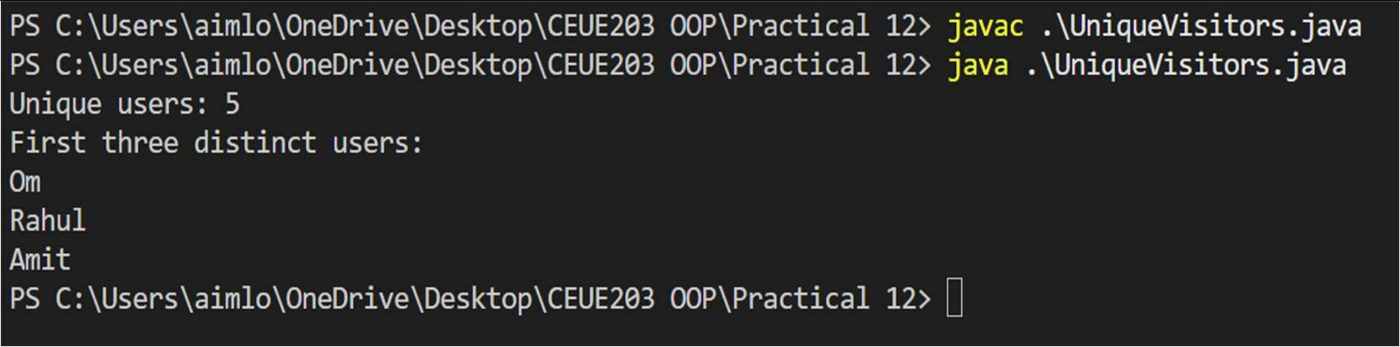
PROBLEM3 | 3. (For Advanced Learners – home) Build a leaderboard from player scores held in a Map and print the top-N sorted by score (ties broken by name); choose the data and sorting details.
CODE | import java.util.*;  public class Leaderboard {  public static void main(String[] args) {  Map<String, Integer> scores = new HashMap<>(); scores.put("Om", 950);  scores.put("Rahul", 870);  scores.put("Nishant", 950);  scores.put("Kushagra", 920);  scores.put("Neha", 870);  // Convert Map entries to List List<Map.Entry<String, Integer>> players =  new ArrayList<>(scores.entrySet());  // Sort by score descending  // If scores are equal, sort by name players.sort((a, b) -> {  int scoreCompare = b.getValue().compareTo(a.getValue());  if (scoreCompare != 0) return scoreCompare;  return a.getKey().compareTo(b.getKey());  });  int N = 3;  System.out.println("Top " + N + " Players:"); for (int i = 0; i < N && i < players.size(); i++) {  Map.Entry<String, Integer> player = players.get(i);  System.out.println(

(i + 1) + ". " +
player.getKey() + " - " + player.getValue()
);
}
}
}
OUTPUT | 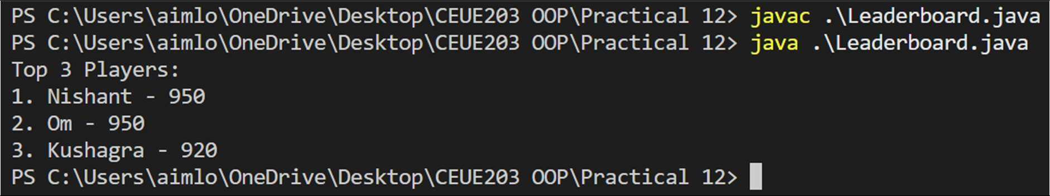

PRACTICAL - 13
Part A — Practice Programs (Hour 1)

PROBLEM1 | 1. Generic containers: a generic Box with get/set and a Pair; use them with different types to show type safety without casts, and write a generic method that returns the first element of any array.
CODE | class Box<T> { private T value;  public void set(T value) { this.value = value;  }  public T get() { return value;  }  }  class Pair<A, B> { private A first; private B second;  public Pair(A first, B second) { this.first = first;  this.second = second;  }  public A getFirst() { return first;  }  public B getSecond() { return second;  }  }  public class GenericDemo {  // Generic method  public static <T> T firstElement(T[] array) { return array[0];  }  public static void main(String[] args) {

// Box with Integer
Box<Integer> intBox = new Box<>(); intBox.set(100);

// Box with String
Box<String> stringBox = new Box<>(); stringBox.set("Hello");

System.out.println("Integer Box: " + intBox.get()); System.out.println("String Box: " + stringBox.get());

// Pair with different types Pair<String, Integer> student =
new Pair<>("Om", 21);

System.out.println("Name: " + student.getFirst()); System.out.println("Age: " + student.getSecond());

// Generic method
String[] names = {"Om", "Rahul", "Amit"}; Integer[] numbers = {10, 20, 30};

System.out.println("First name: " + firstElement(names)); System.out.println("First number: " + firstElement(numbers));
}
}
OUTPUT | 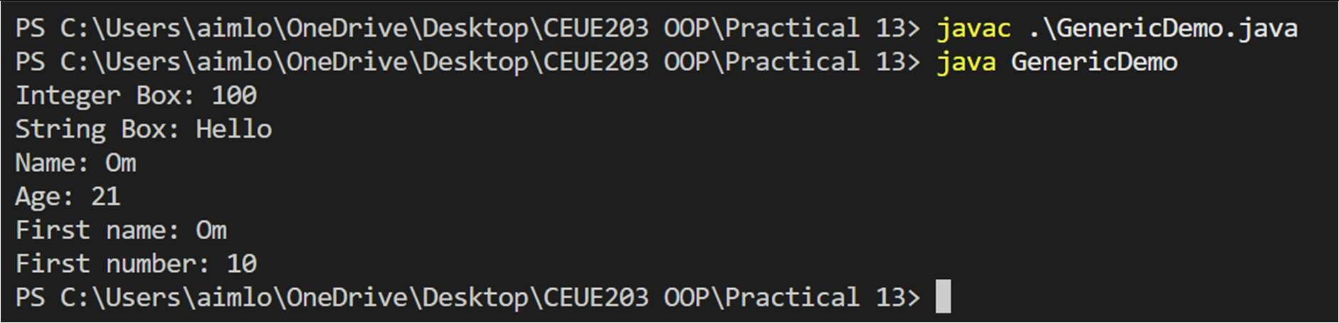
PROBLEM2 | 2. Bounded stats: a generic method double average(N[] values) that works for Integer[], Double[] and Long[]; note why it refuses non-Number types.
CODE | public class BoundedStats {  public static <N extends Number> double average(N[] values) { double sum = 0;  for (N value : values) {  sum += value.doubleValue();  }

return sum / values.length;
}
public static void main(String[] args) { Integer[] integers = {10, 20, 30, 40};
Double[] doubles = {10.5, 20.5, 30.5};
Long[] longs = {100L, 200L, 300L};

System.out.println("Integer average: " + average(integers)); System.out.println("Double average: " + average(doubles)); System.out.println("Long average: " + average(longs));
}
}
OUTPUT | 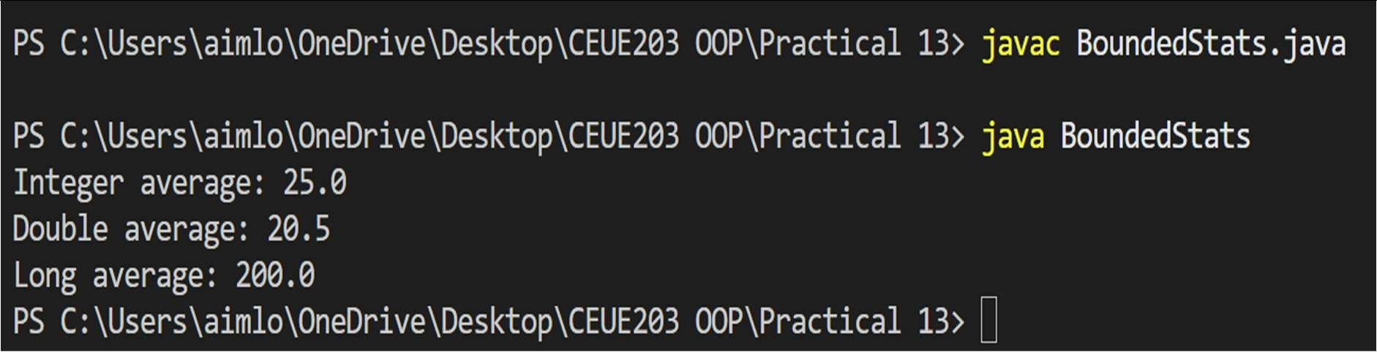
PROBLEM3 | 3. (For Advanced Learners – home) Implement a small generic container of your choice (e.g. a stack) backed by an array, reuse it for two different types, and handle the empty case sensibly.
CODE | class MyStack<T> {  private T[] stack; private int top;  @SuppressWarnings("unchecked") public MyStack(int size) {  stack = (T[]) new Object[size]; top = -1;  }  public void push(T value) {  if (top == stack.length - 1) { System.out.println("Stack is full!"); return;  }  stack[++top] = value;  }

public T pop() { if (top == -1) {
System.out.println("Stack is empty!");
return null;
}

return stack[top--];
}
public T peek() { if (top == -1) {
System.out.println("Stack is empty!"); return null;
}

return stack[top];
}

public boolean isEmpty() { return top == -1;
}
}

public class GenericStackDemo {

public static void main(String[] args) {

// Integer stack
MyStack<Integer> intStack = new MyStack<>(5);

intStack.push(10); intStack.push(20); intStack.push(30);

System.out.println("Integer stack pop: "
+ intStack.pop());

System.out.println("Integer stack peek: "
+ intStack.peek());

// String stack
MyStack<String> stringStack = new MyStack<>(5);

 |  |  | stringStack.push("Java"); stringStack.push("Python"); stringStack.push("C++");
System.out.println("String stack pop: "
+ stringStack.pop());
System.out.println("String stack peek: "
+ stringStack.peek());
// Empty case
while (!stringStack.isEmpty()) { stringStack.pop();
}
 | } | } | System.out.println("Trying to pop from empty stack:"); stringStack.pop();
OUTPUT | 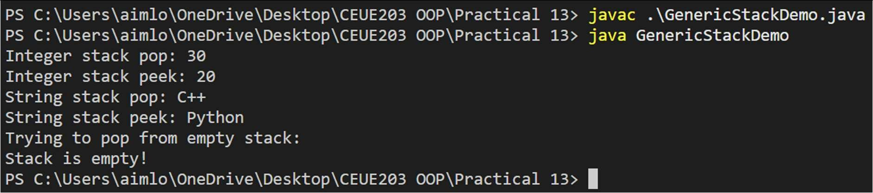

PRACTICAL - 14
Part A — Practice Programs (Hour 1)

PROBLEM1 | 1. Assemble and test: build a tiny layered app (a model, a service using an ArrayList, and a menu main), then write two or three JUnit @Test methods checking that adding increases the count and an invalid action throws — practice before testing MiniBank.
CODE | public class Account { private String name; private double balance;  public Account(String name, double balance) { this.name = name;  this.balance = balance;  }  public String getName() { return name;  }  public double getBalance() { return balance;  }  }  import java.util.ArrayList; public class AccountService {  private ArrayList<Account> accounts = new ArrayList<>();  public void addAccount(Account account) { if (account == null) {  throw new IllegalArgumentException( "Account cannot be null"  );  }  accounts.add(account);  }  public int getCount() { return accounts.size();  }  public Account getAccount(int index) {

if (index < 0 || index >= accounts.size()) { throw new IllegalArgumentException(
"Invalid account index"
);
}

return accounts.get(index);
}
}
import java.util.Scanner; public class Main {
public static void main(String[] args) { Scanner sc = new Scanner(System.in);
AccountService service = new AccountService(); int choice;
do {
System.out.println("\n1. Add Account"); System.out.println("2. View Account Count"); System.out.println("3. Exit"); System.out.print("Enter choice: ");

choice = sc.nextInt(); sc.nextLine();

switch (choice) { case 1:
System.out.print("Enter name: "); String name = sc.nextLine();

System.out.print("Enter balance: "); double balance = sc.nextDouble();

service.addAccount(
new Account(name, balance)
);

System.out.println("Account added!"); break;

case 2:
System.out.println(
"Total accounts: " + service.getCount()
);

break;

case 3:
System.out.println("Exiting..."); break;

default:
System.out.println("Invalid choice!");
}
} while (choice != 3);

sc.close();
}
}

import java.util.Scanner; public class Main {
public static void main(String[] args) { Scanner sc = new Scanner(System.in);
AccountService service = new AccountService(); int choice;
do {
System.out.println("\n1. Add Account"); System.out.println("2. View Account Count"); System.out.println("3. Exit"); System.out.print("Enter choice: ");

choice = sc.nextInt(); sc.nextLine();

switch (choice) { case 1:
System.out.print("Enter name: "); String name = sc.nextLine();

System.out.print("Enter balance: "); double balance = sc.nextDouble();

service.addAccount(
new Account(name, balance)
);

System.out.println("Account added!");

break;

case 2:
System.out.println(
"Total accounts: " + service.getCount()
);
break;

case 3:
System.out.println("Exiting..."); break;

default:
System.out.println("Invalid choice!");
}
} while (choice != 3);

sc.close();
}
}

public class AccountServiceTest {

public static void main(String[] args) { addingAccountIncreasesCount(); addingTwoAccountsIncreasesCountByTwo(); invalidAccountThrowsException();

System.out.println("\nAll tests passed!");
}

static void addingAccountIncreasesCount() { AccountService service = new AccountService();
service.addAccount(new Account("Om", 1000)); if (service.getCount() != 1) {
throw new AssertionError("Count should be 1");
}

System.out.println("Test 1 passed");
}

static void addingTwoAccountsIncreasesCountByTwo() { AccountService service = new AccountService();

service.addAccount(new Account("Om", 1000));
service.addAccount(new Account("Rahul", 2000));

if (service.getCount() != 2) {
throw new AssertionError("Count should be 2");
}

System.out.println("Test 2 passed");
}

static void invalidAccountThrowsException() { AccountService service = new AccountService();

try {
service.addAccount(null);
throw new AssertionError("Exception was not thrown");
} catch (IllegalArgumentException expected) { System.out.println("Test 3 passed");
}
}
}
OUTPUT | 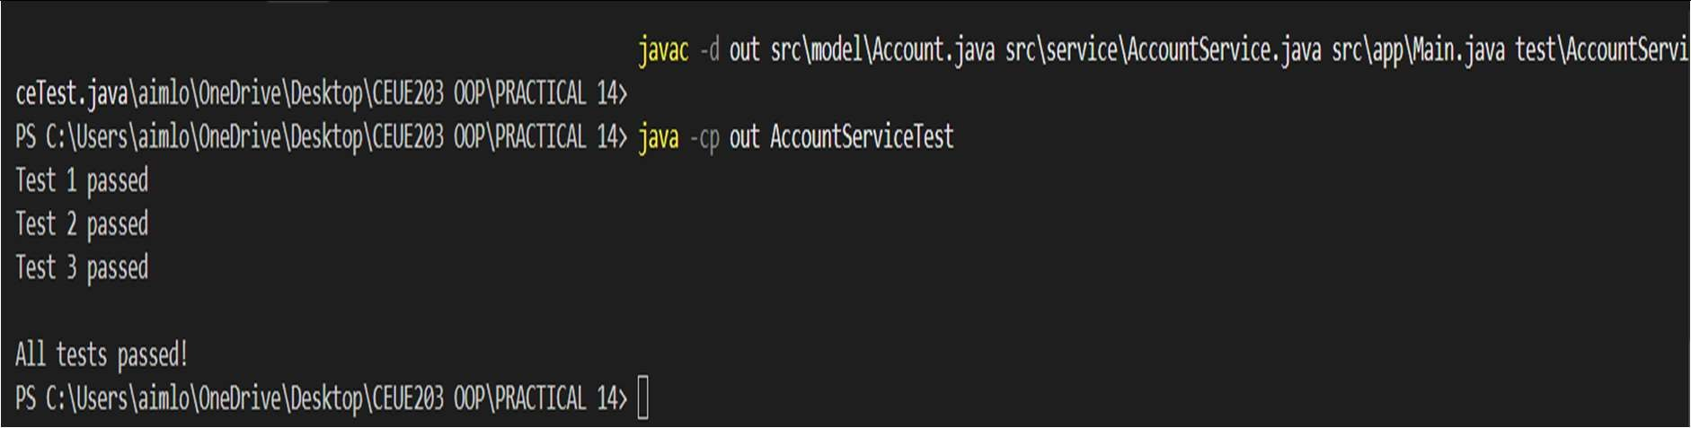
PROBLEM2 | 2. (For Advanced Learners – home) Organise that app into packages, build a runnable JAR, and add a test that saves and reloads its data unchanged.
CODE | package model;  import java.io.Serializable;  public class Account implements Serializable { private static final long serialVersionUID = 1L;  private String name; private double balance;  public Account(String name, double balance) { this.name = name;  this.balance = balance;  }

public String getName() { return name;
}

public double getBalance() { return balance;
}
}

package service; import model.Account;
import java.util.ArrayList; import java.io.*;

public class AccountService {
private ArrayList<Account> accounts = new ArrayList<>();

public void addAccount(Account account) { if (account == null) {
throw new IllegalArgumentException( "Account cannot be null"
);
}

accounts.add(account);
}

public int getCount() { return accounts.size();
}

public Account getAccount(int index) {
if (index < 0 || index >= accounts.size()) { throw new IllegalArgumentException(
"Invalid account index"
);
}

return accounts.get(index);
}

public void saveData(String filename) throws IOException { try (ObjectOutputStream out = new ObjectOutputStream(
new FileOutputStream(filename))) {
out.writeObject(accounts);

}
}

@SuppressWarnings("unchecked") public void loadData(String filename)
throws IOException, ClassNotFoundException {
try (ObjectInputStream in = new ObjectInputStream( new FileInputStream(filename))) {
accounts = (ArrayList<Account>) in.readObject();
}
}
}

package app;

import model.Account;
import service.AccountService; import java.util.Scanner;

public class Main {
public static void main(String[] args) { Scanner sc = new Scanner(System.in);
AccountService service = new AccountService(); int choice;
do {
System.out.println("\n1. Add Account"); System.out.println("2. View Account Count"); System.out.println("3. Save Data"); System.out.println("4. Load Data"); System.out.println("5. Exit"); System.out.print("Enter choice: ");

choice = sc.nextInt(); sc.nextLine();

try {
switch (choice) { case 1:
System.out.print("Enter name: "); String name = sc.nextLine();

System.out.print("Enter balance: "); double balance = sc.nextDouble();

service.addAccount(
new Account(name, balance)
);

System.out.println("Account added!"); break;

case 2:
System.out.println(
"Total accounts: " + service.getCount()
);
break;

case 3:
service.saveData("accounts.dat"); System.out.println("Data saved!"); break;

case 4:
service.loadData("accounts.dat"); System.out.println("Data loaded!"); break;

case 5:
System.out.println("Exiting..."); break;

default:
System.out.println("Invalid choice!");
}
} catch (Exception e) {
System.out.println("Error: " + e.getMessage());
}
} while (choice != 5); sc.close();
}
}

import model.Account;
import service.AccountService;

public class AccountServiceTest {
public static void main(String[] args) throws Exception { AccountService original = new AccountService();

original.addAccount(new Account("Om", 5000));
original.addAccount(new Account("Rahul", 3000)); original.saveData("test-accounts.dat");
AccountService restored = new AccountService(); restored.loadData("test-accounts.dat");

if (original.getCount() != restored.getCount()) {
throw new AssertionError("Account count does not match");
}

for (int i = 0; i < original.getCount(); i++) { Account a = original.getAccount(i); Account b = restored.getAccount(i);

if (!a.getName().equals(b.getName())
|| a.getBalance() != b.getBalance()) {
throw new AssertionError("Account data does not match");
}
}

System.out.println("Save and reload test passed!");
}
}

manifest.mf
Main-Class: app.Main
OUTPUT | 